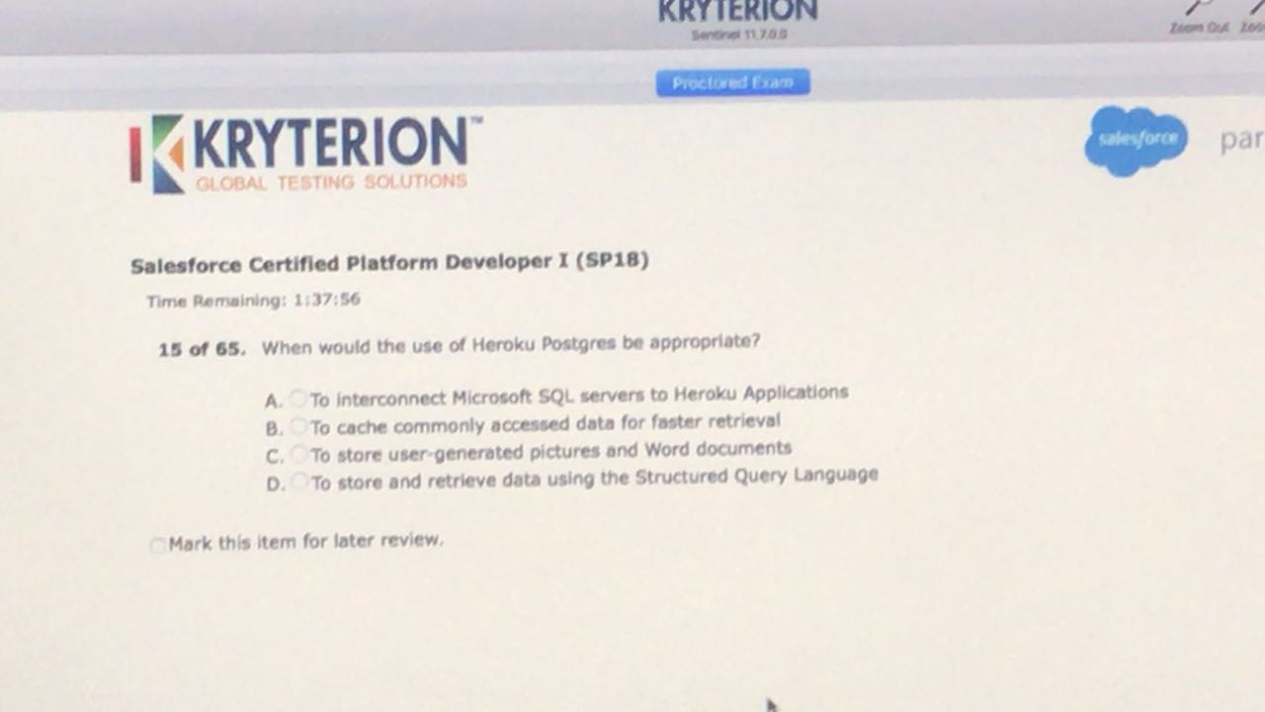

Answer : D

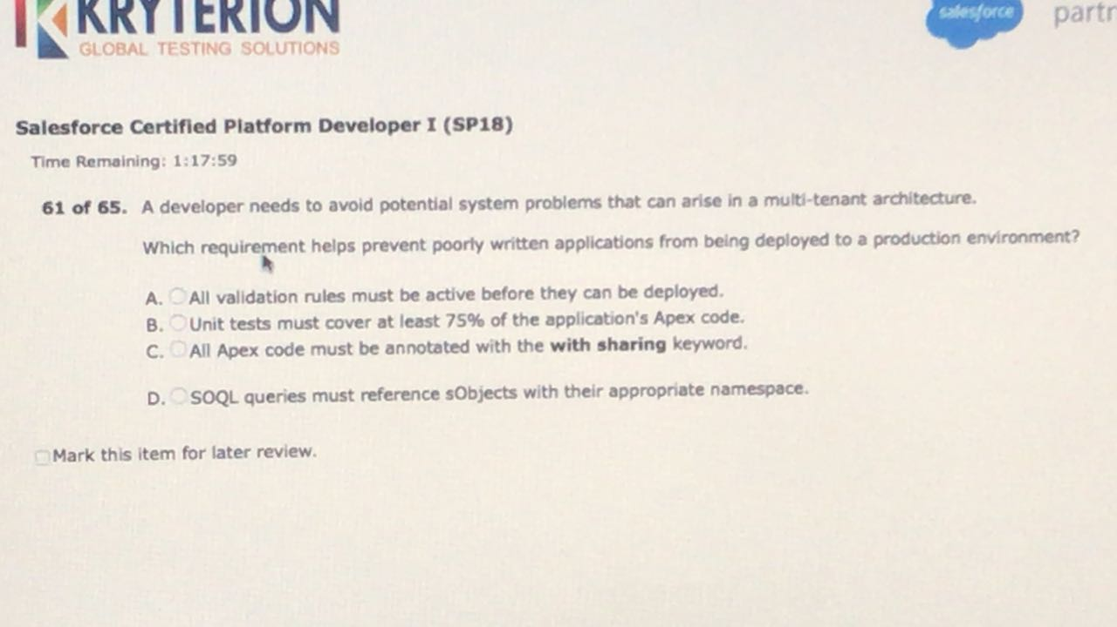

Ans:B

<https://developer.salesforce.com/page/Multi_Tenant_Architecture>

Submitted unit tests must cover no less than 75 percent of the application’s source code.

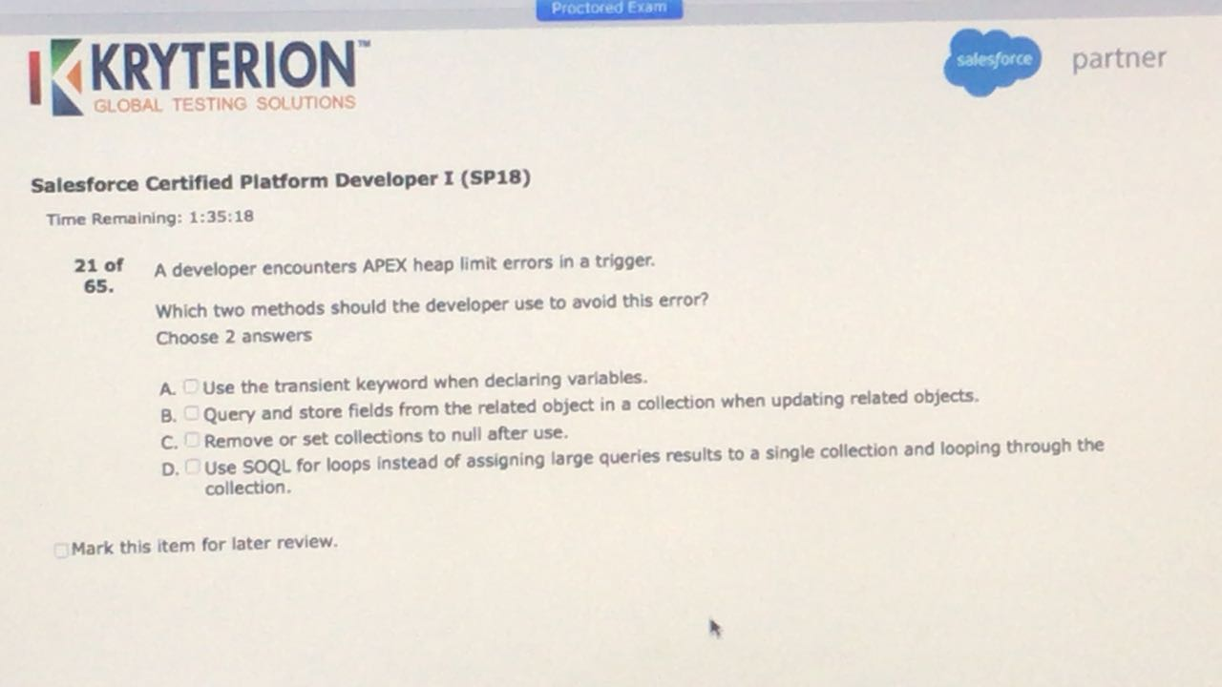

* C, D

<https://help.salesforce.com/articleView?id=000004186&type=1>

Construct methods and loops that allow variables to go out of scope as soon as they are no longer needed.

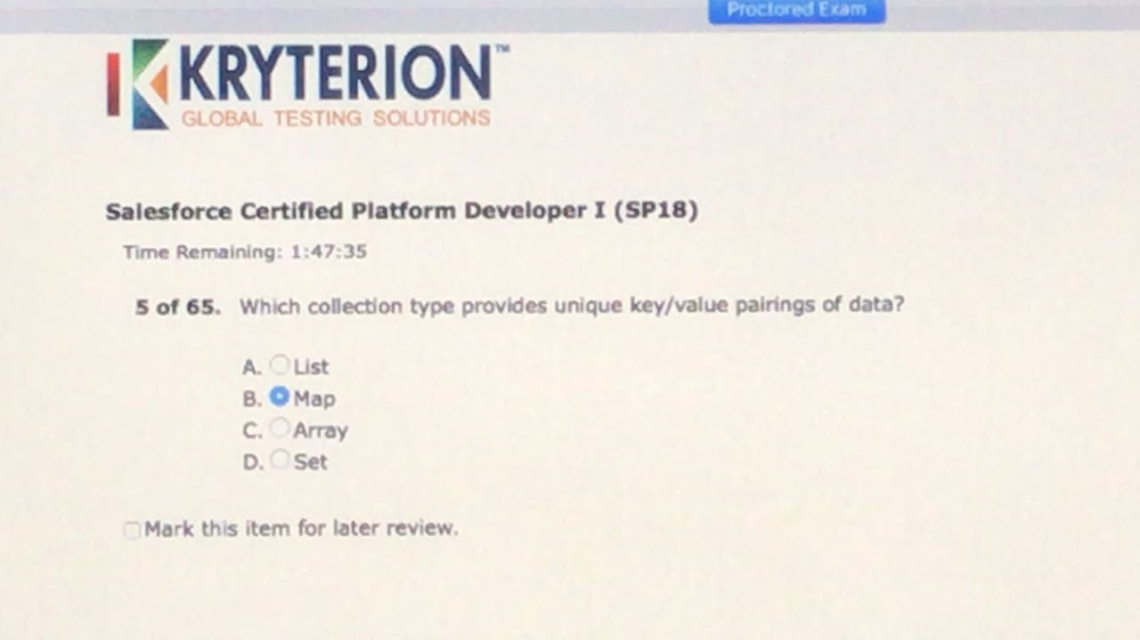

* B

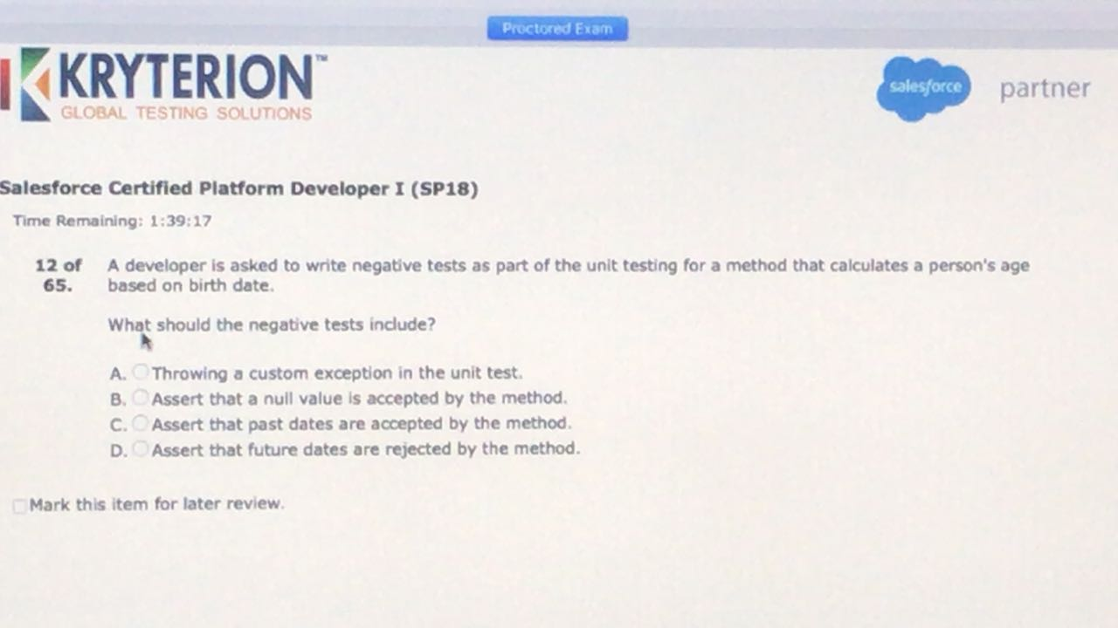

* D

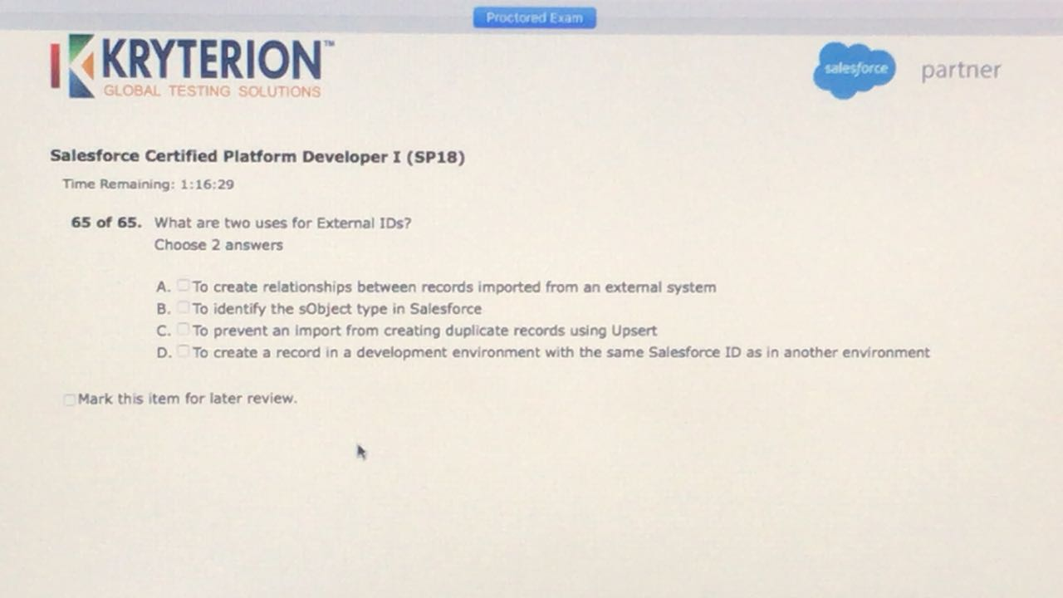

A.C.

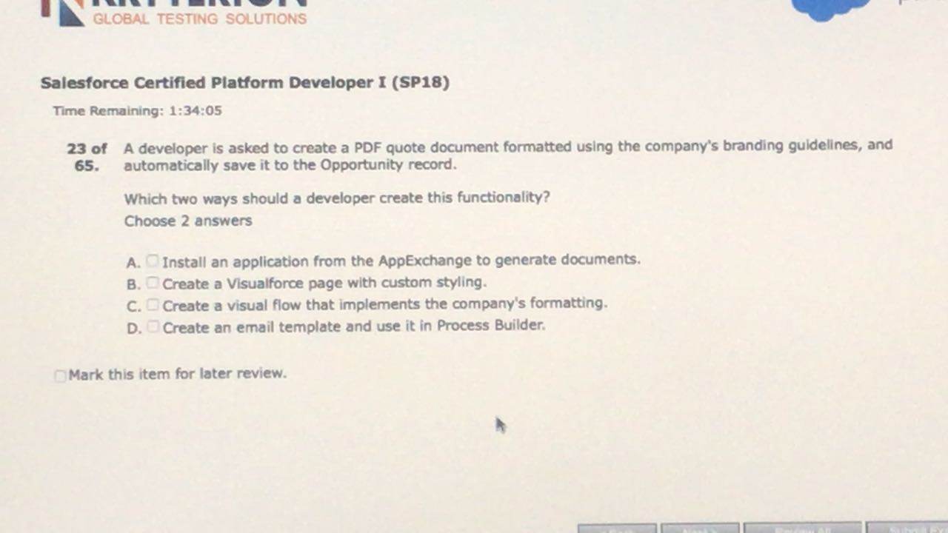

A.B.

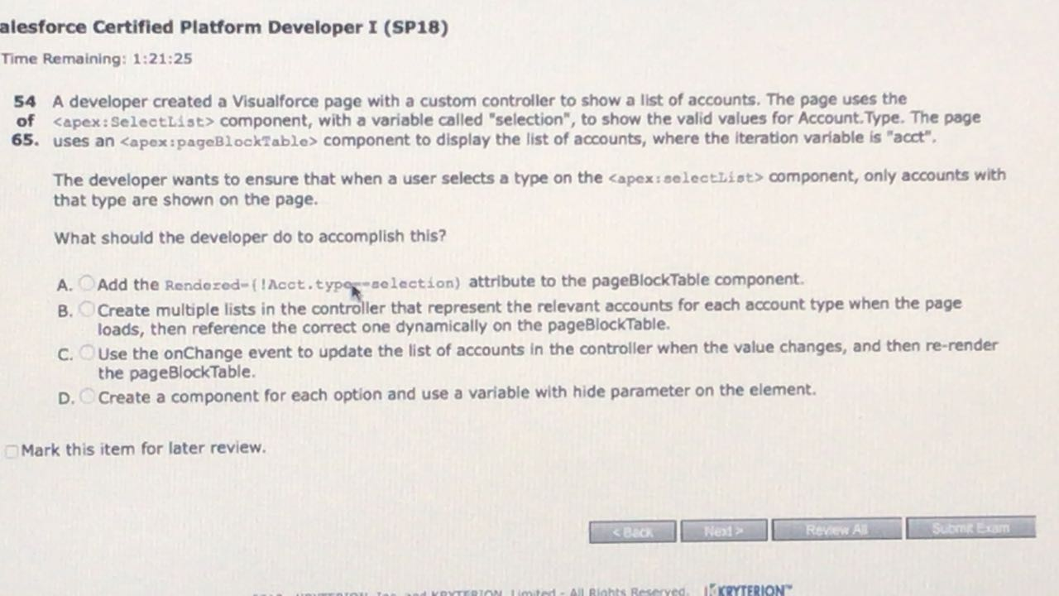

C.

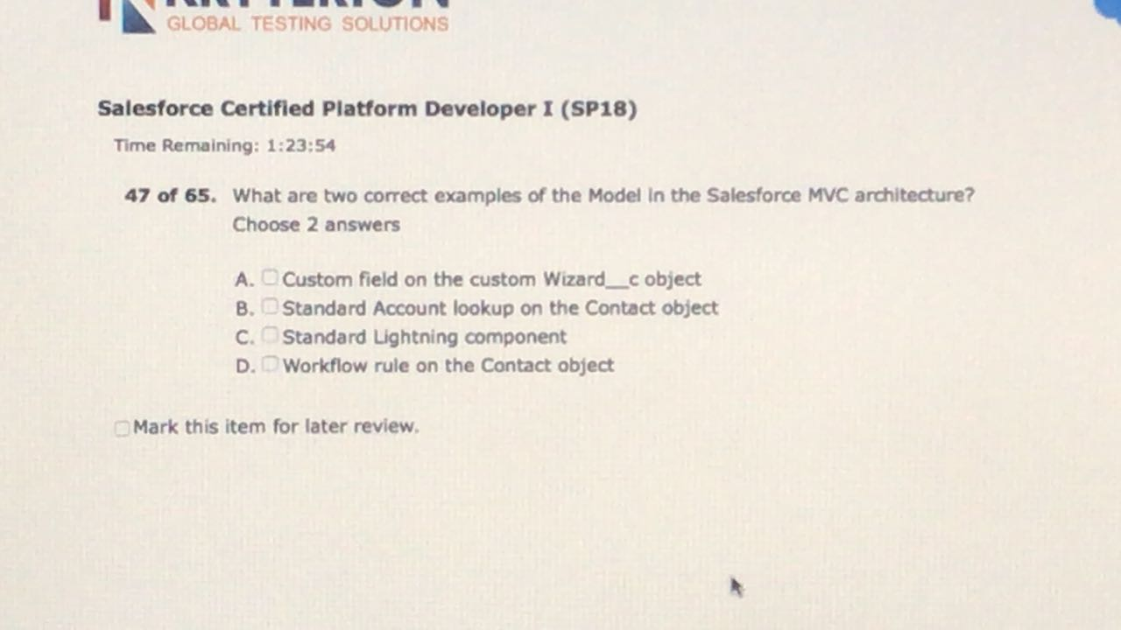

A.B

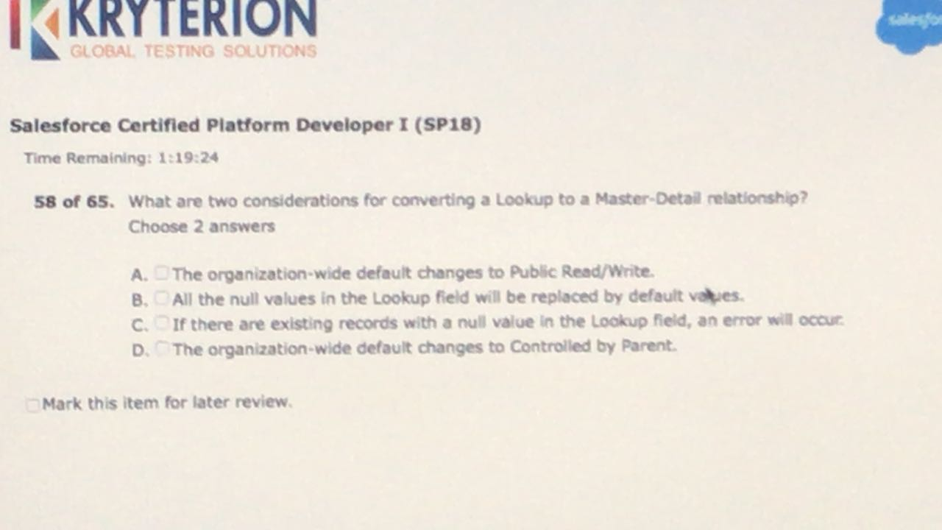

C.D

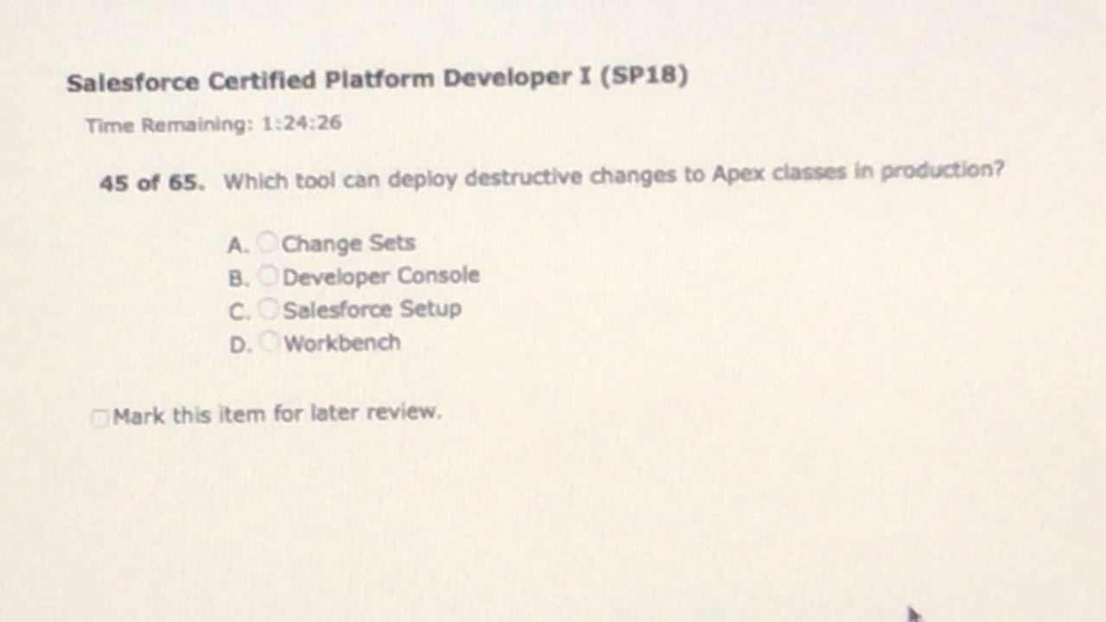

D.

Workbench , force.com IDE

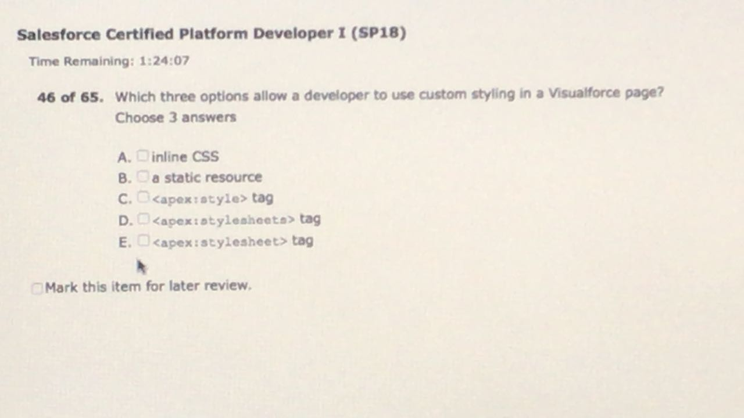

A.B.E.

<https://developer.salesforce.com/docs/atlas.en-us.pages.meta/pages/pages_styling_custom.htm>

https://developer.salesforce.com/docs/atlas.en-us.pages.meta/pages/pages_styling.htm

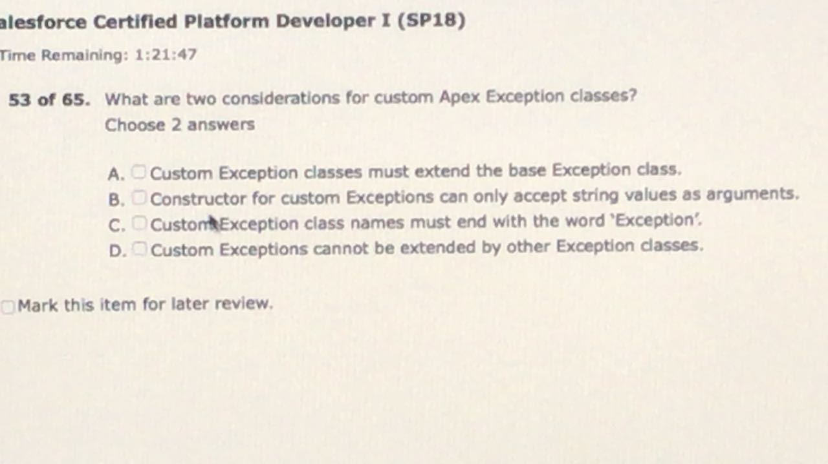

A.C

https://developer.salesforce.com/docs/atlas.en-us.apexcode.meta/apexcode/apex_exception_custom.htm

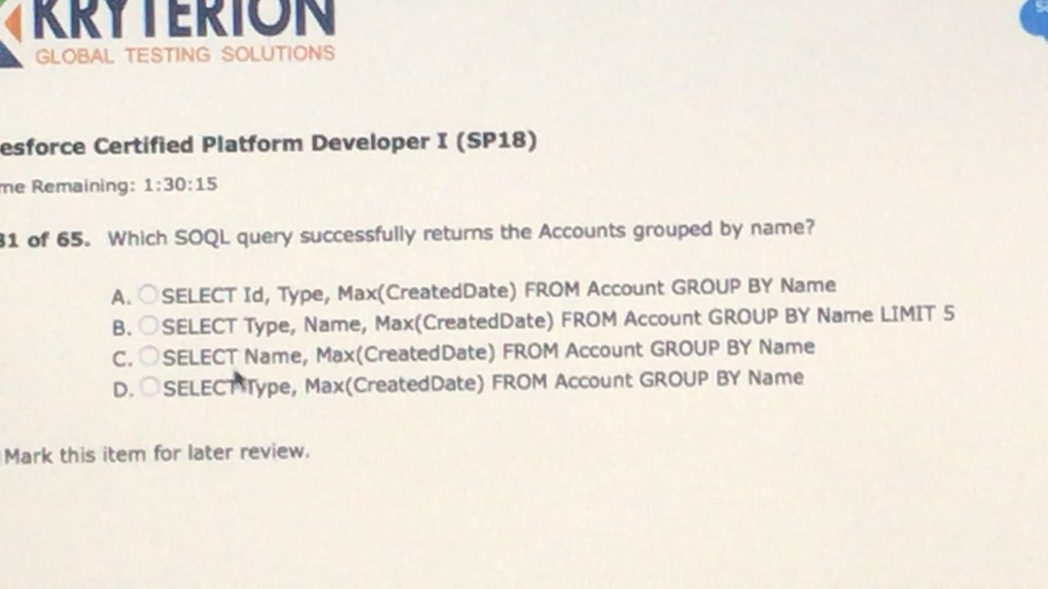

C

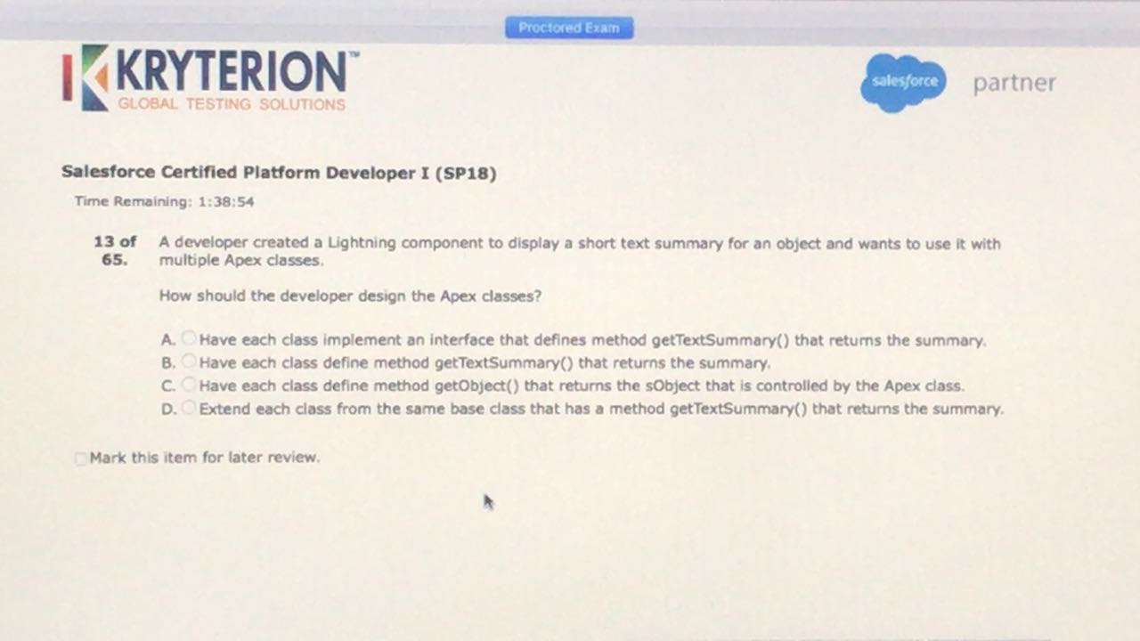

D

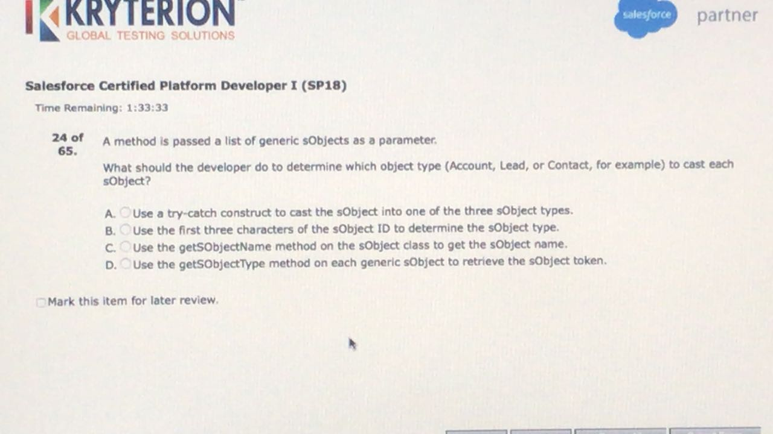

* D

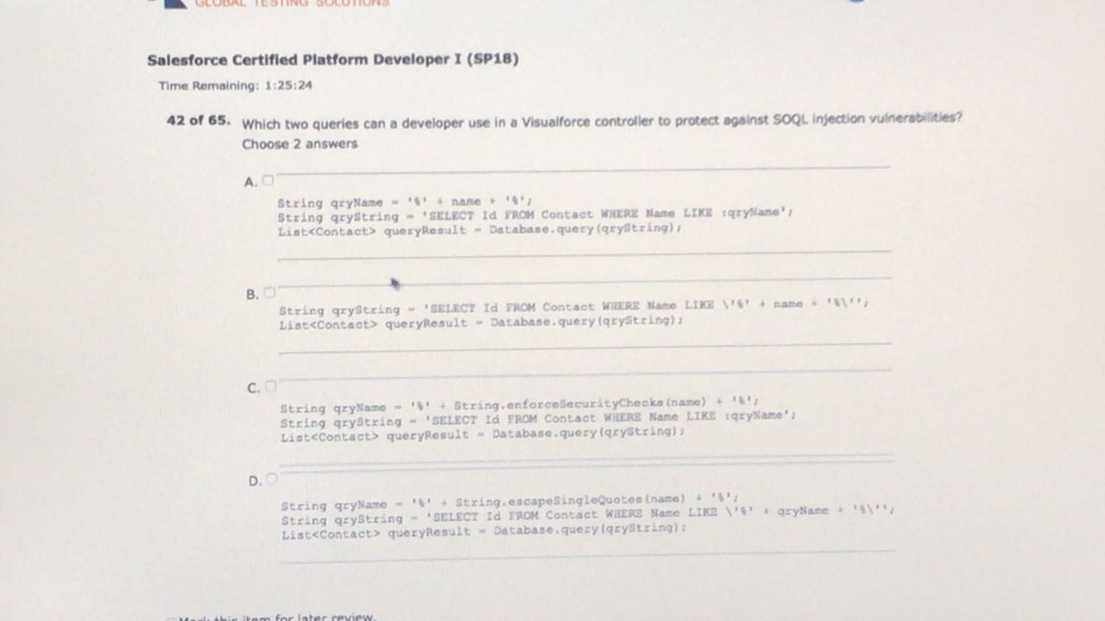

* B, D

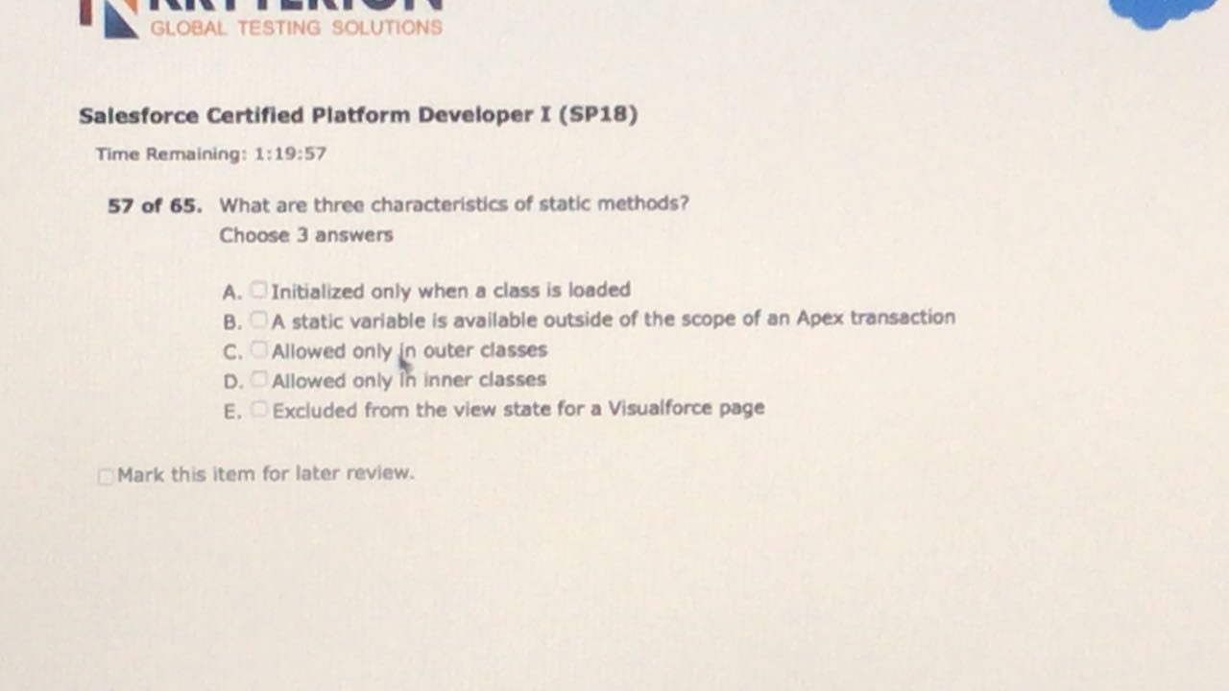

* A, C, E

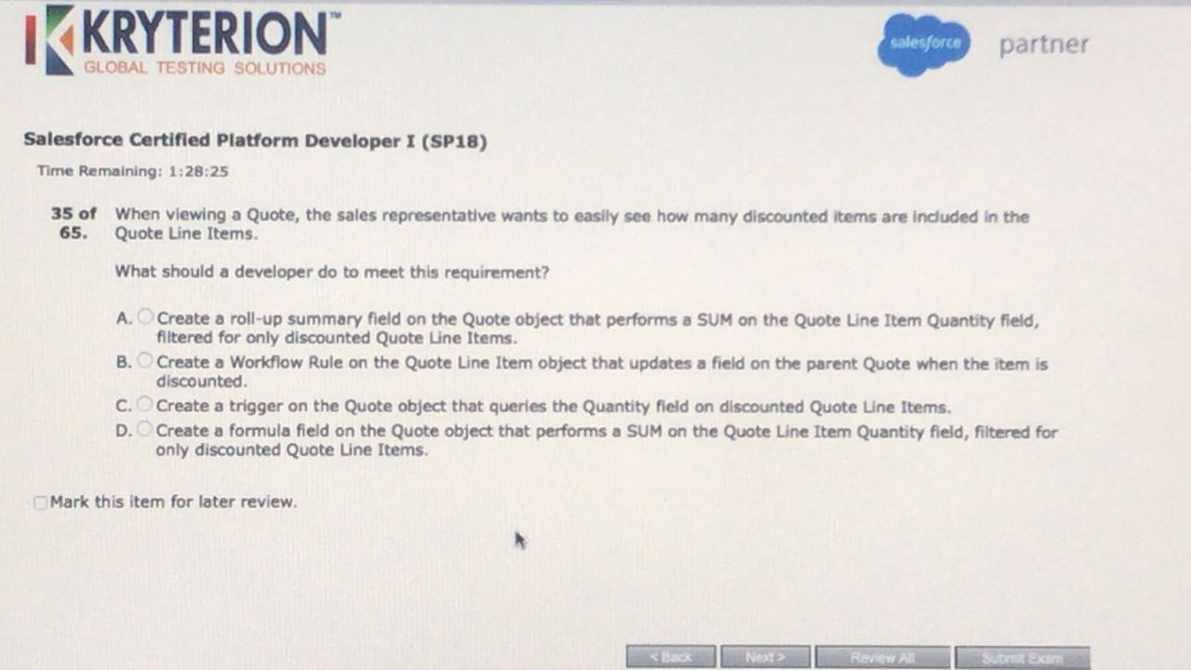

A.

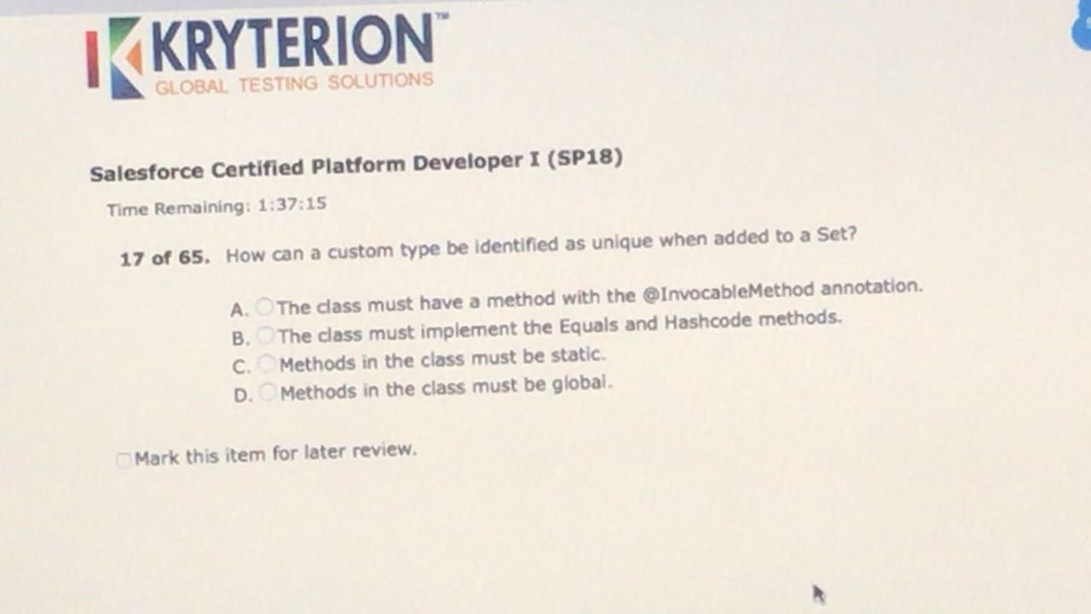

B

https://developer.salesforce.com/docs/atlas.en-us.apexcode.meta/apexcode/langCon_apex_collections_maps_keys_userdefined.htm

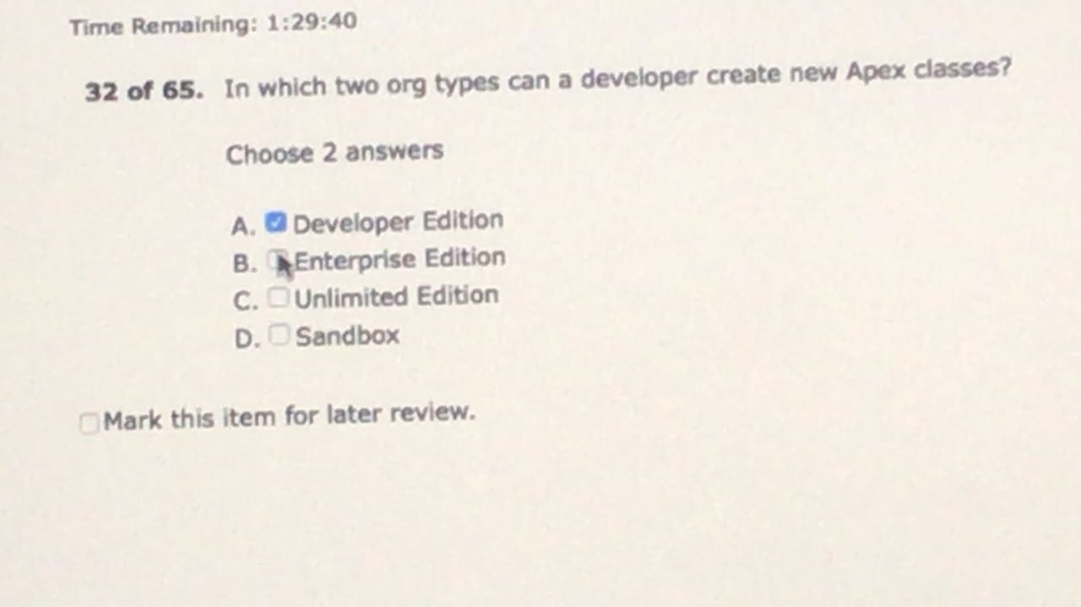

A.D.

This from the help & training link regarding Apex: *"You can add, edit, or delete Apex using the Salesforce user interface only in a Developer Edition, a Salesforce Enterprise Edition trial organization, or sandbox organization. In a Salesforce production organization, you can only make changes to Apex by using the metadata API*

*deploy call, the Force.com IDE, or the Force.com Migration Tool."*

https://developer.salesforce.com/forums/?id=906F00000008lb5IAA

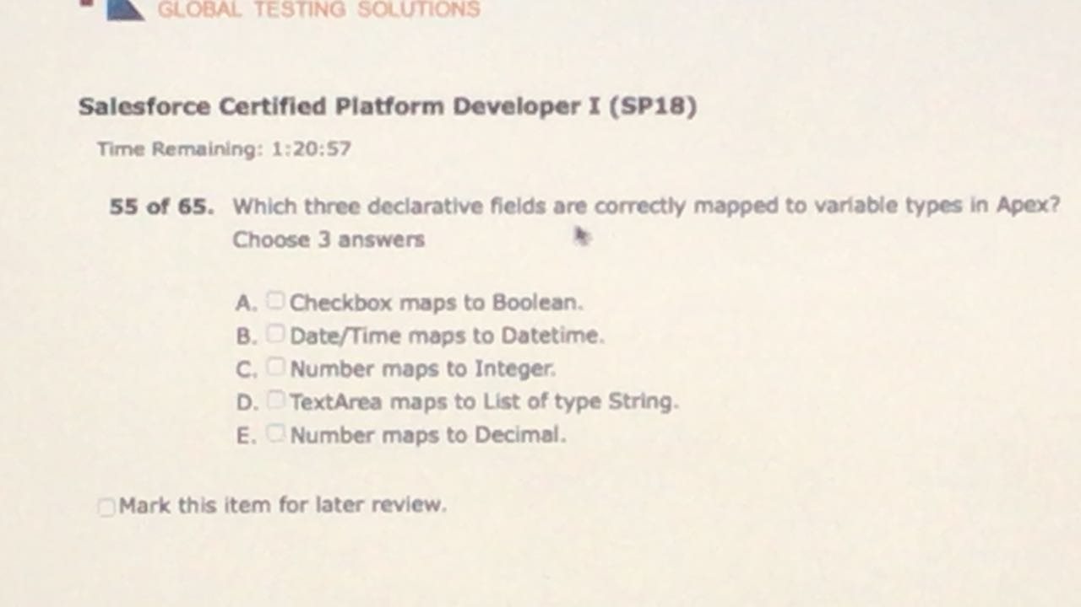

A.B.E.

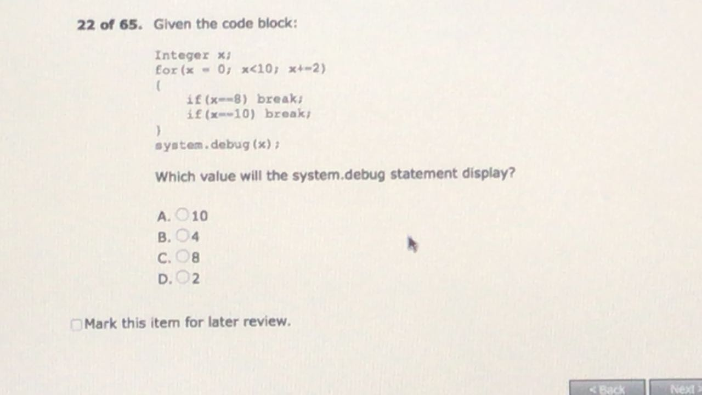

C.

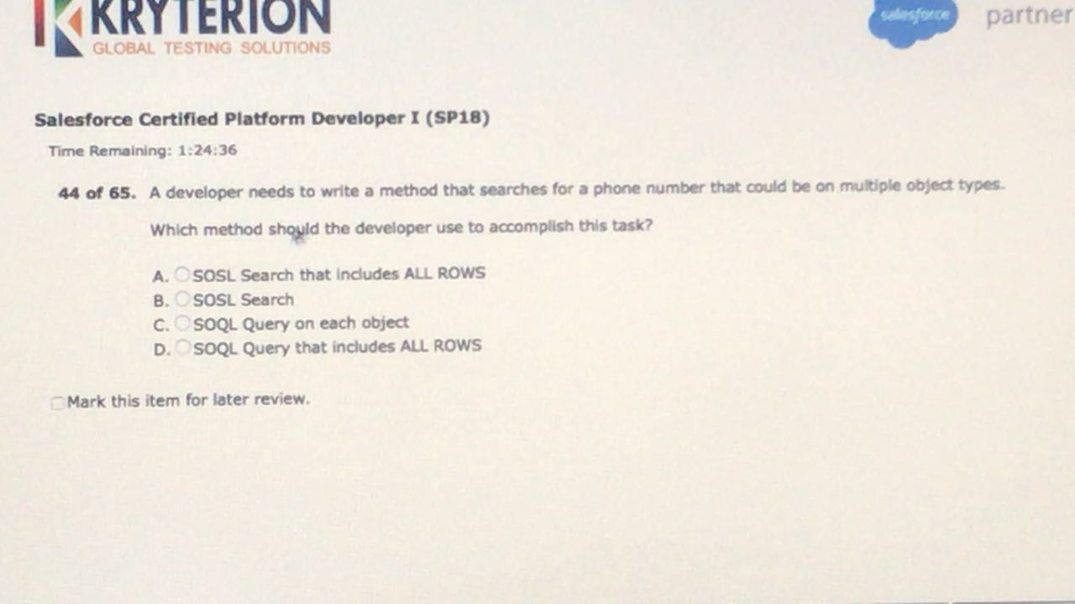

B

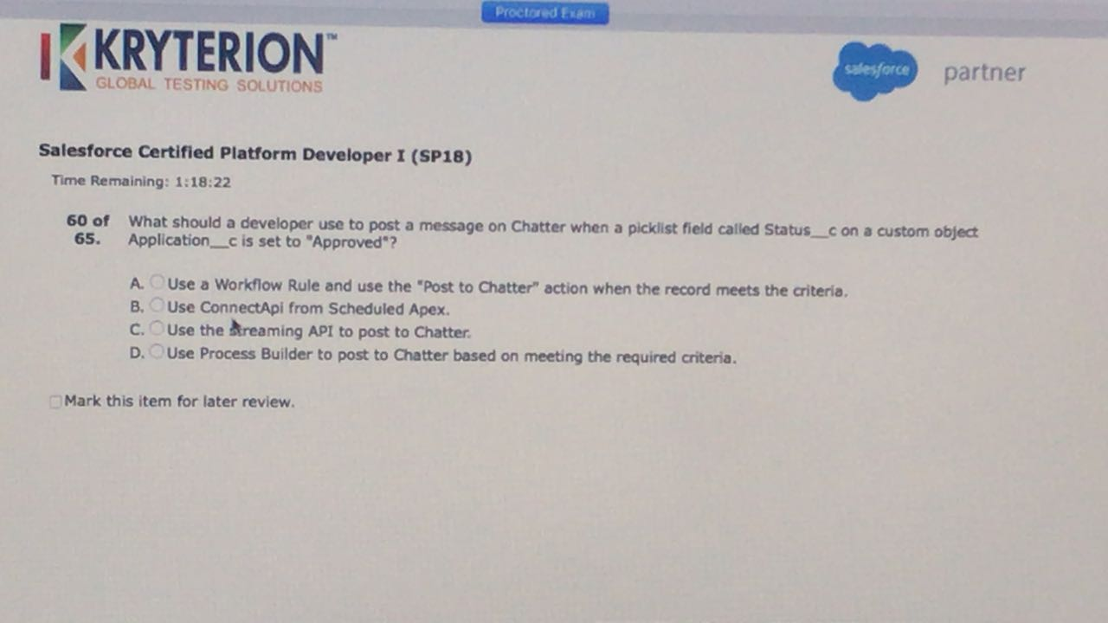

D.

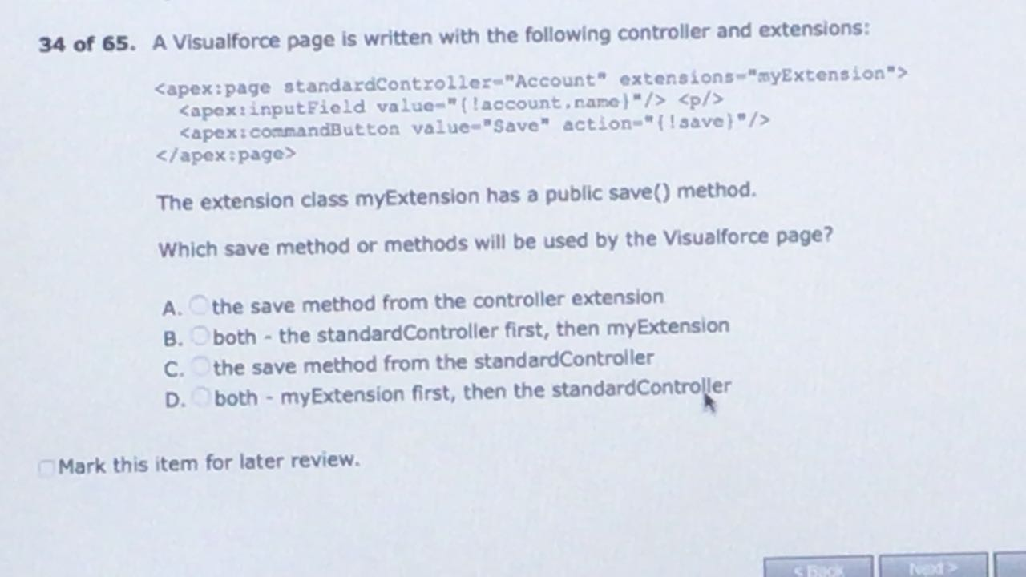

A.

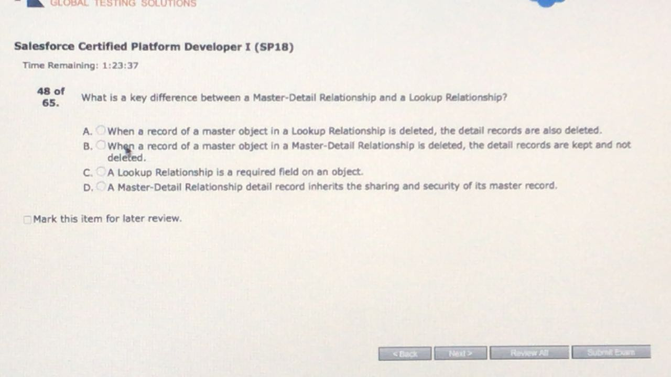

D.

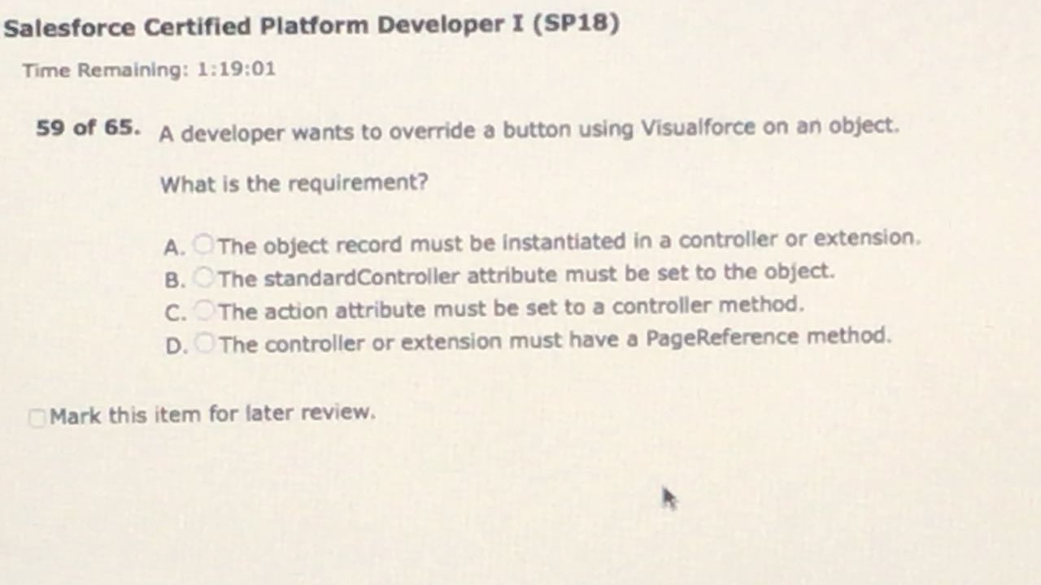

B

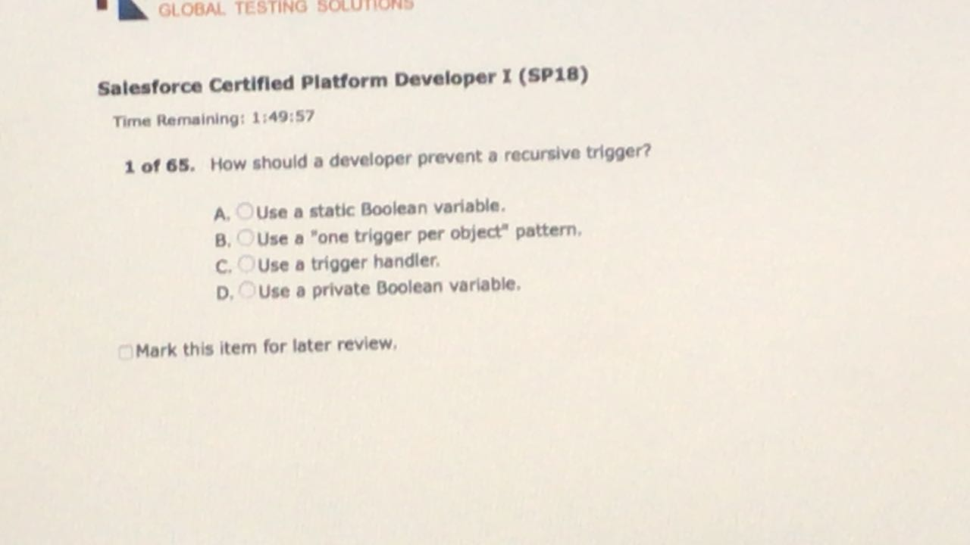

A.

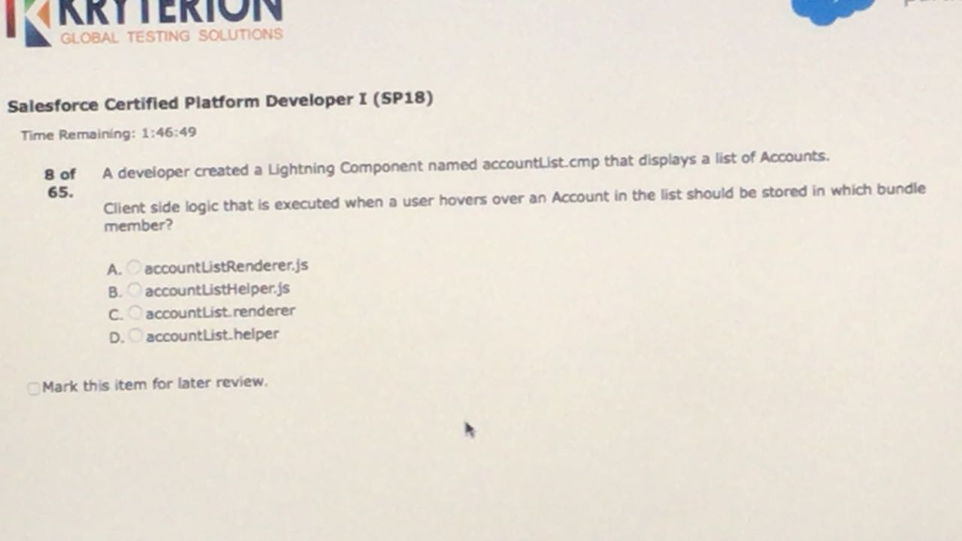

B.

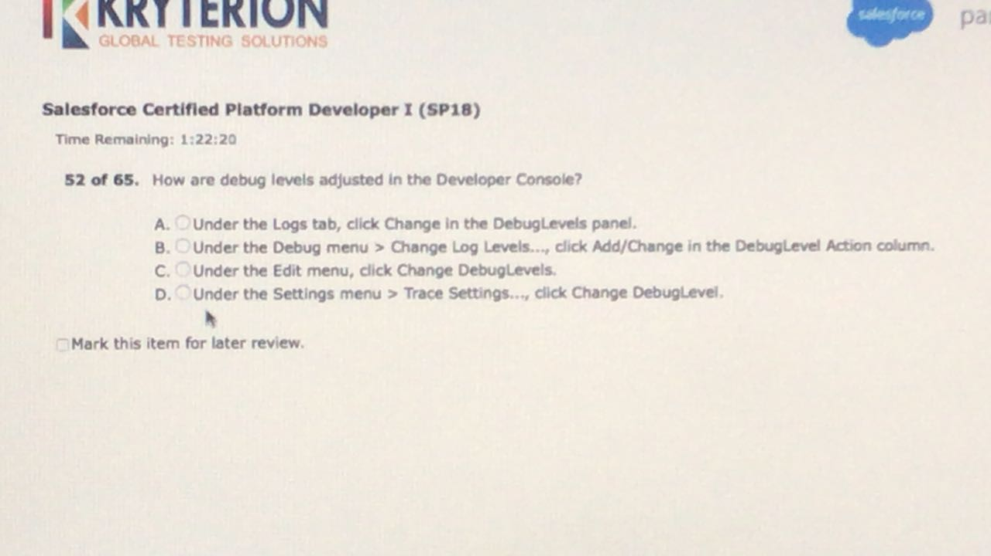

B.

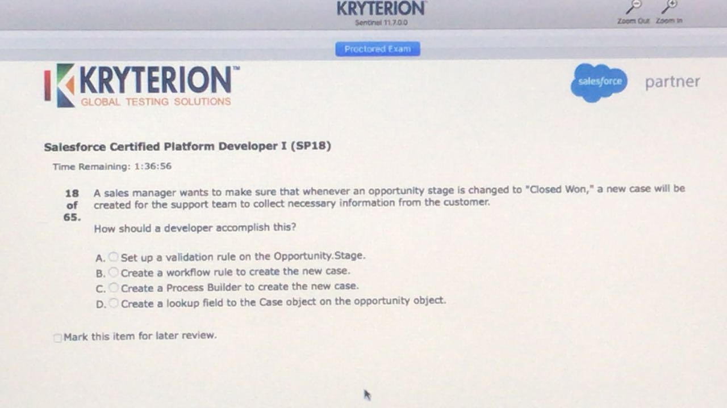

C.

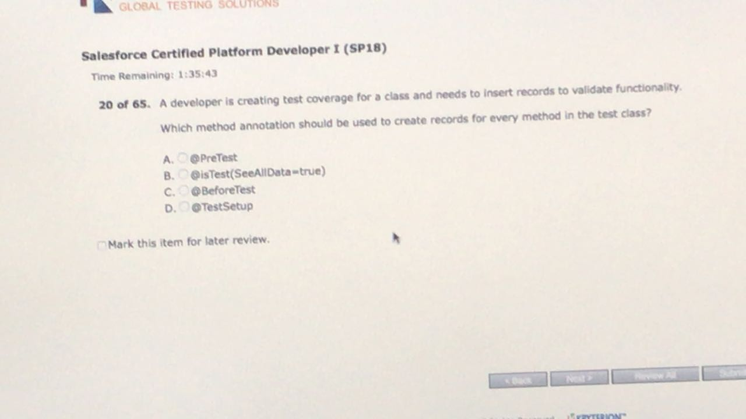

D.

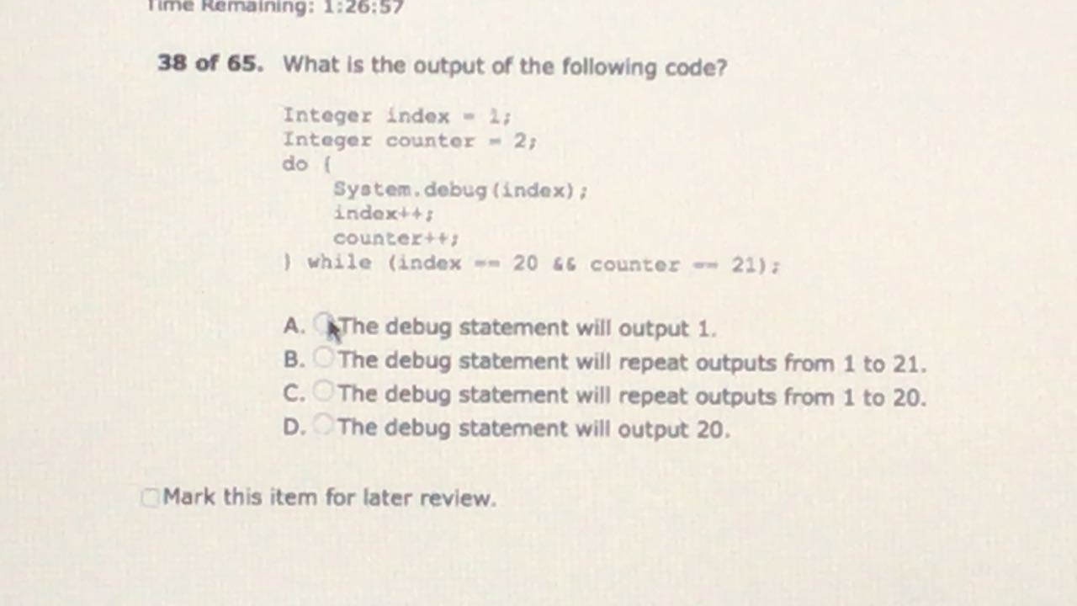

A

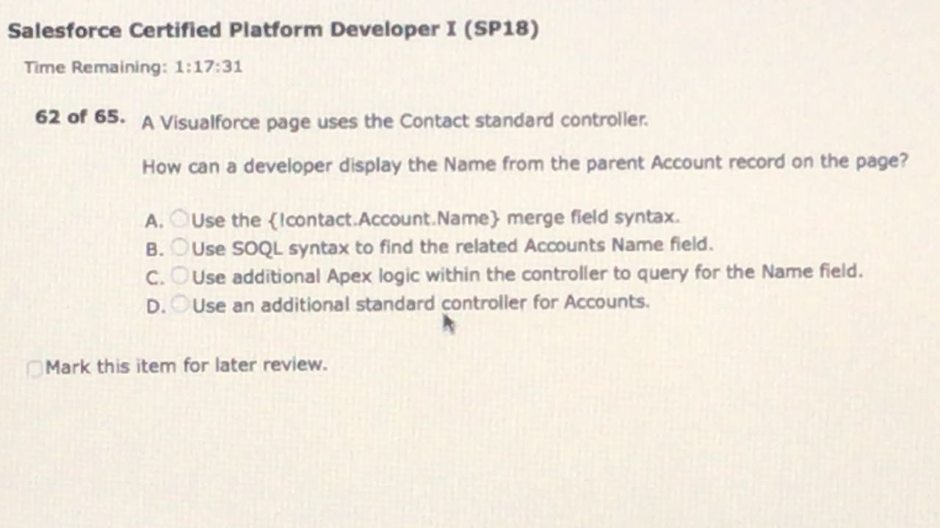

A.

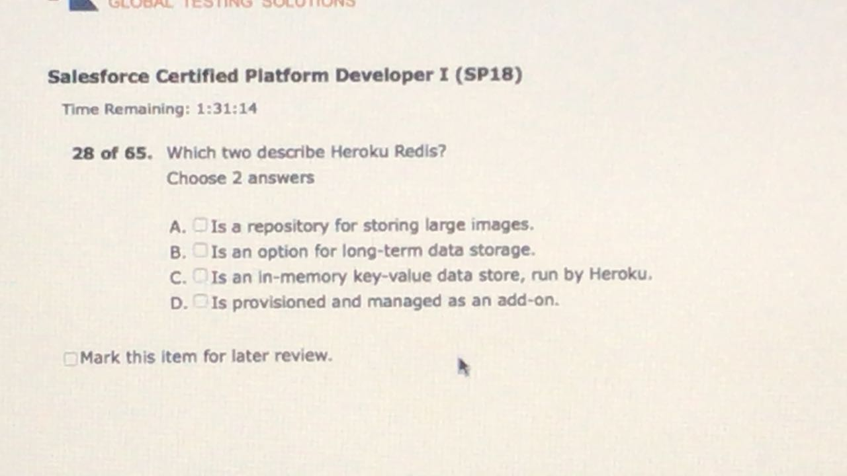

* C, D

Heroku Redis is an in-memory key-value data store, run by Heroku, that is provisioned and managed as an [add-on](https://elements.heroku.com/addons/heroku-redis).

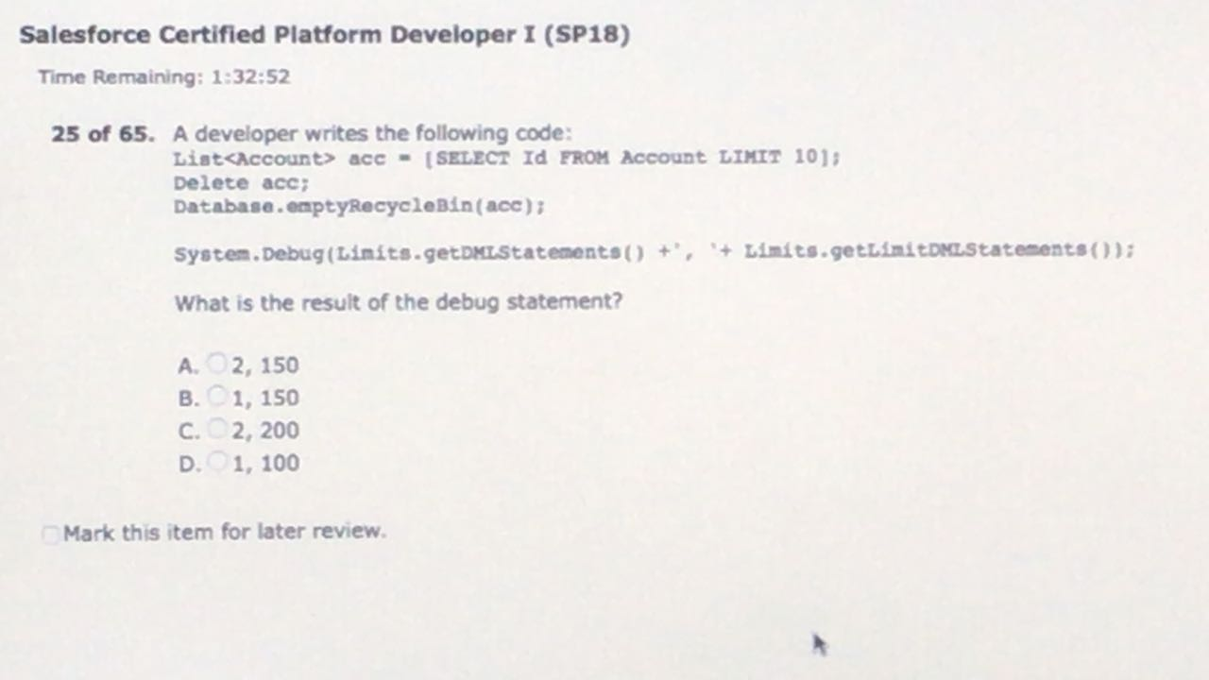

A.

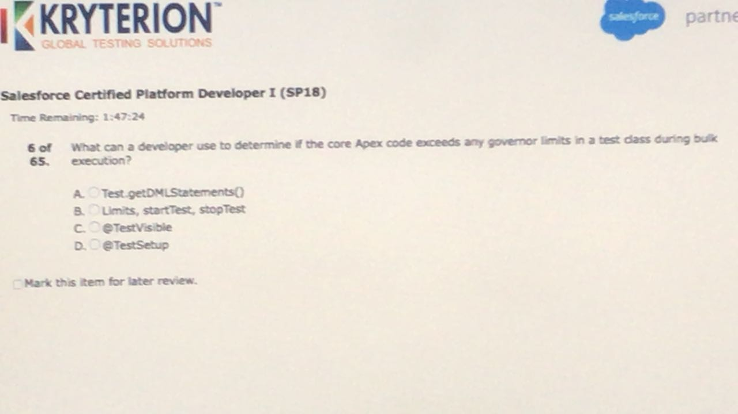

B.

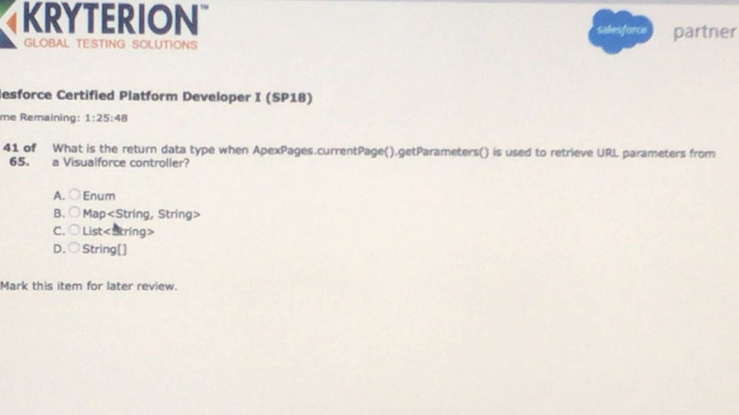

B

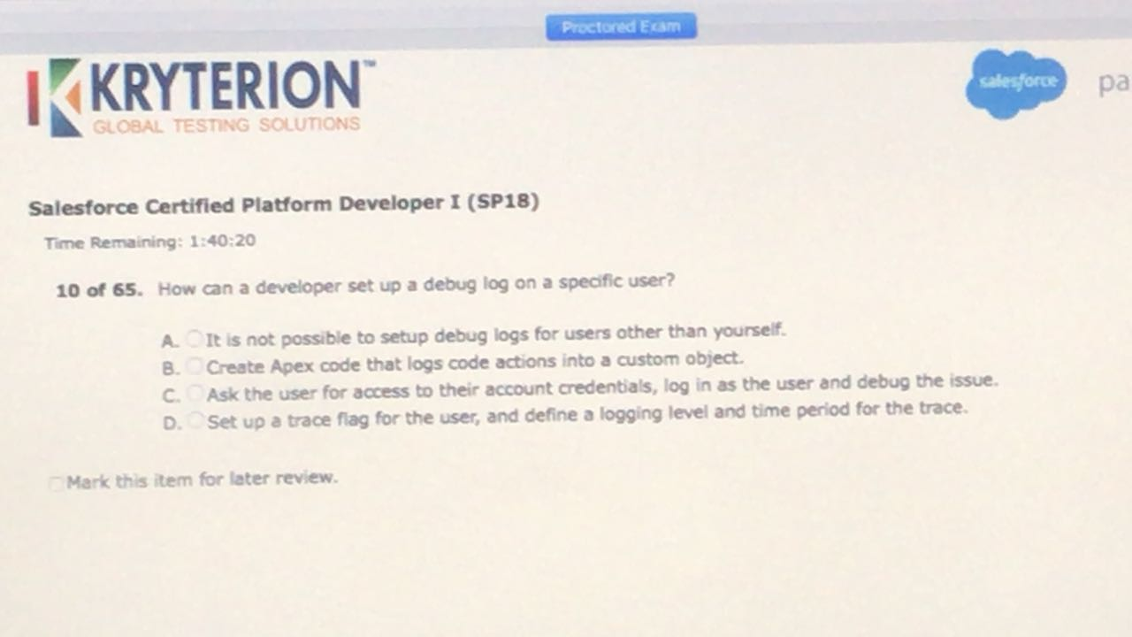

D.

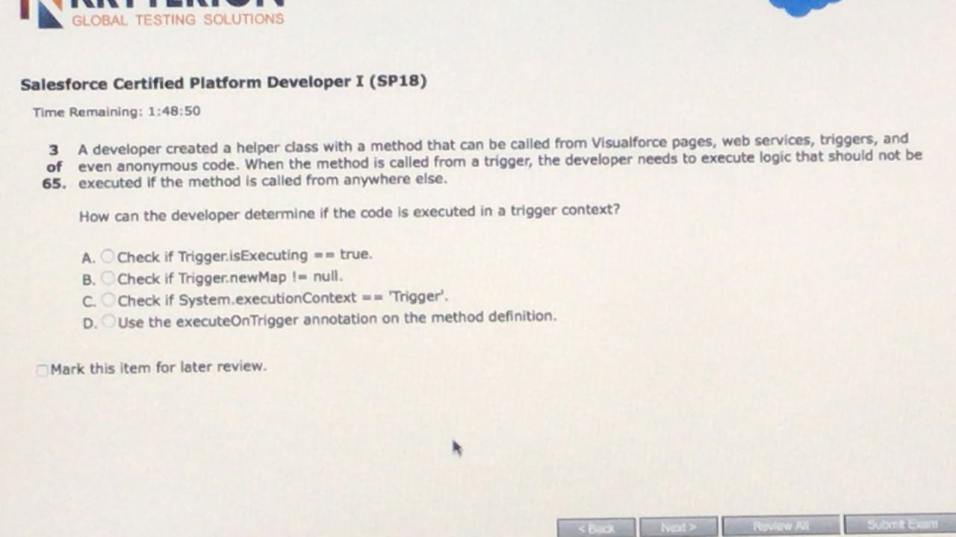

A.

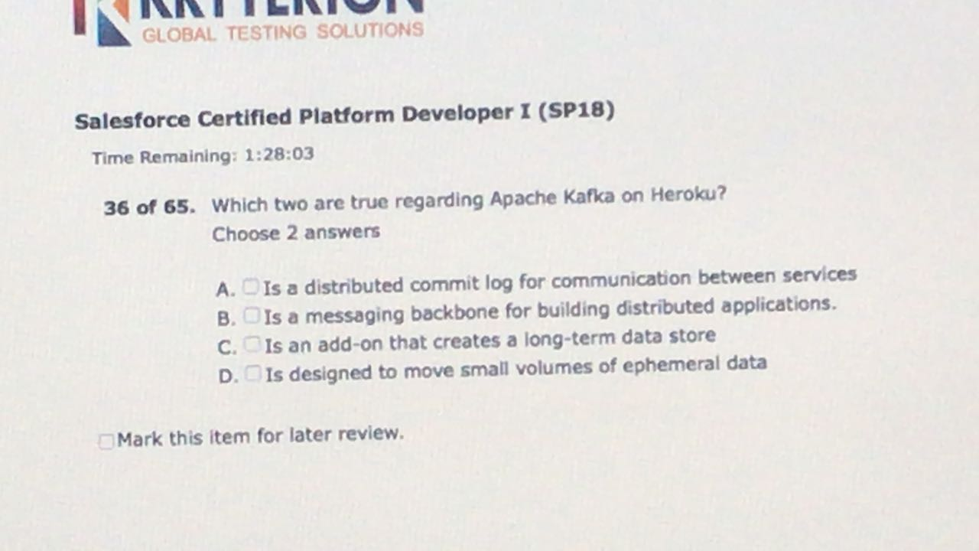

A.B.

Apache Kafka is a distributed commit log for fast, fault-tolerant communication between producers and consumers using message based topics. Kafka provides the messaging backbone for building a new generation of distributed applications capable of handling billions of events and millions of transactions, and is designed to move large volumes of ephemeral data with a high degree of reliability and fault tolerance.

https://devcenter.heroku.com/articles/kafka-on-heroku

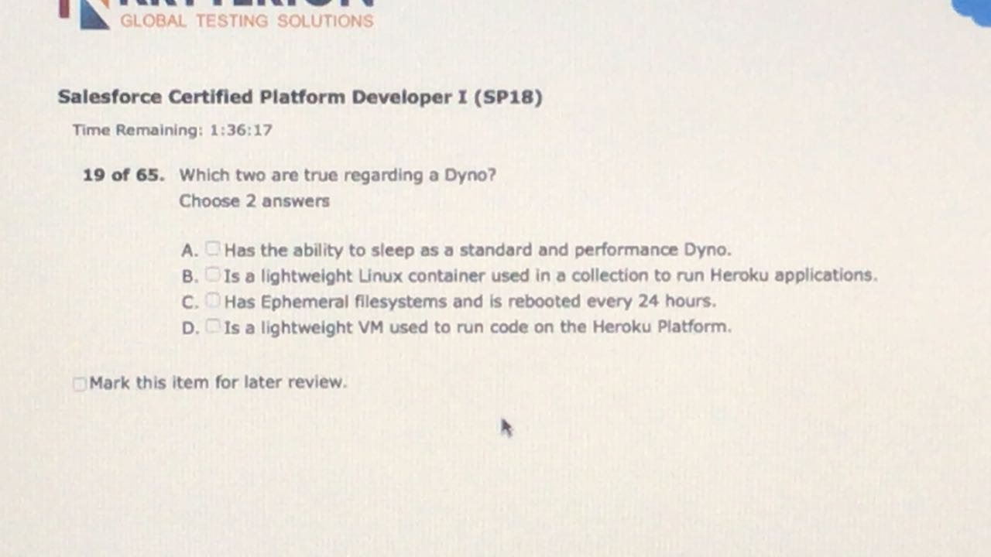

B,C

The [Heroku Platform](https://www.heroku.com/platform) uses the container model to run and scale all Heroku apps. The containers used at Heroku are called “dynos.”

https://www.heroku.com/dynos

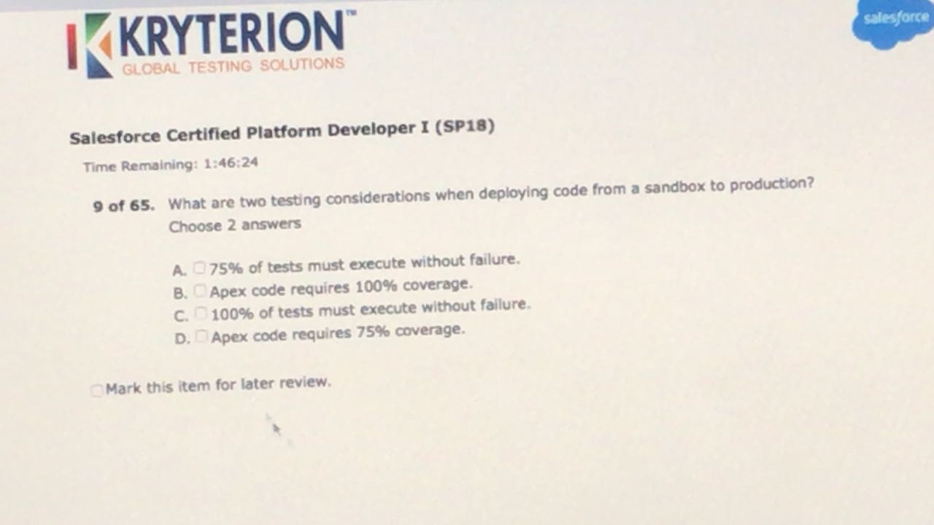

C,D

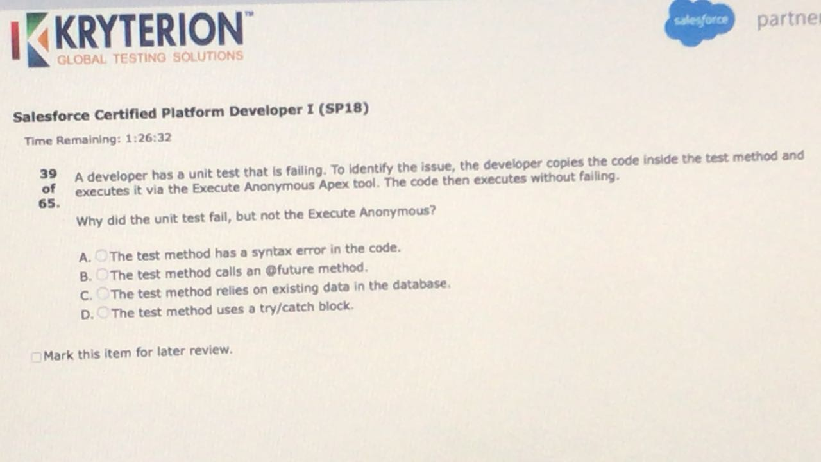

* C

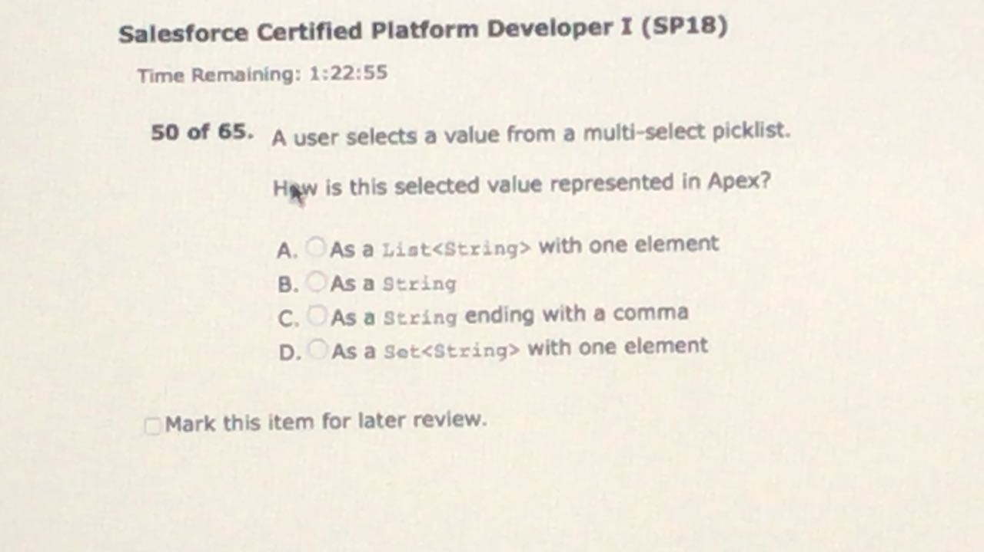

B.

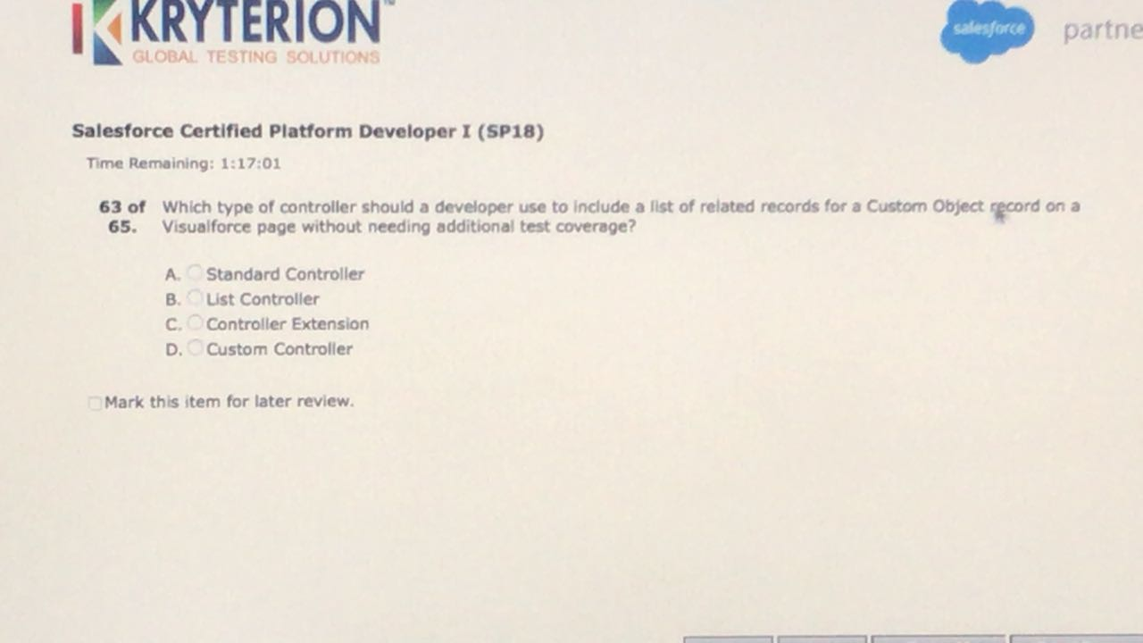

A.

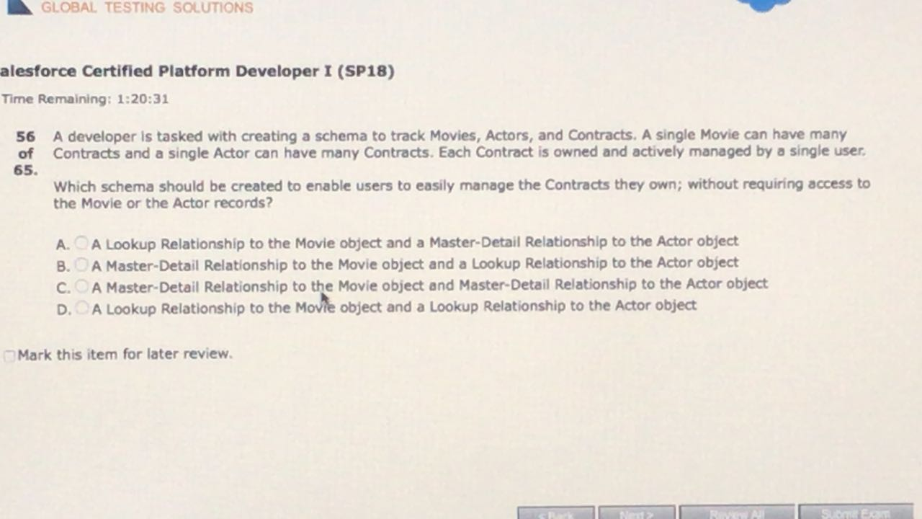

D

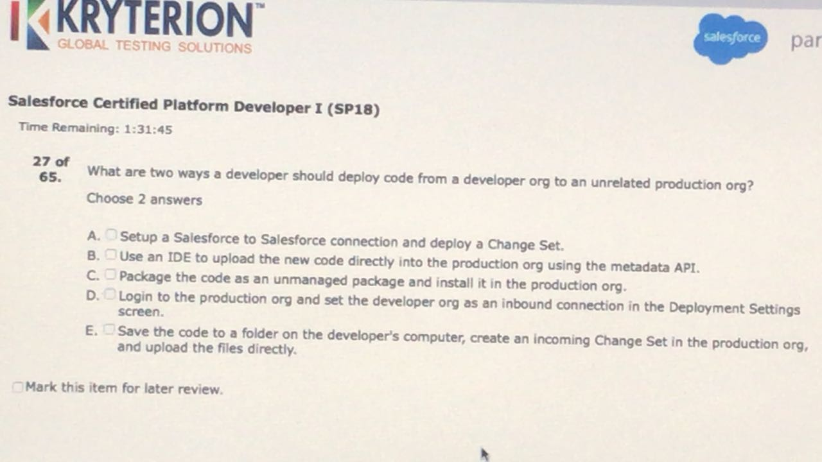

B,C

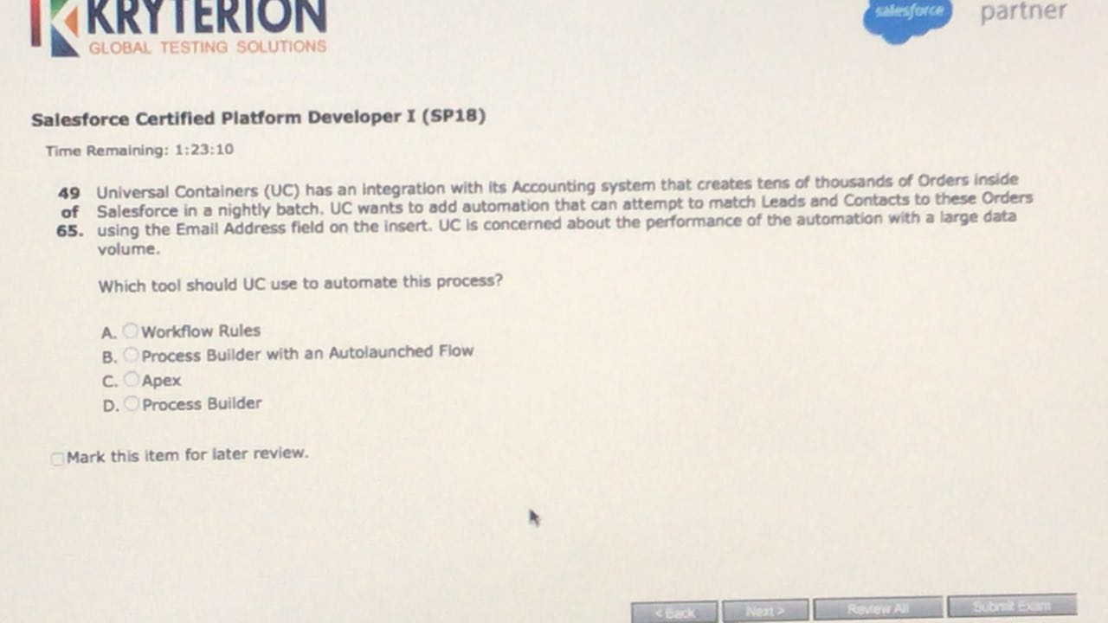

C

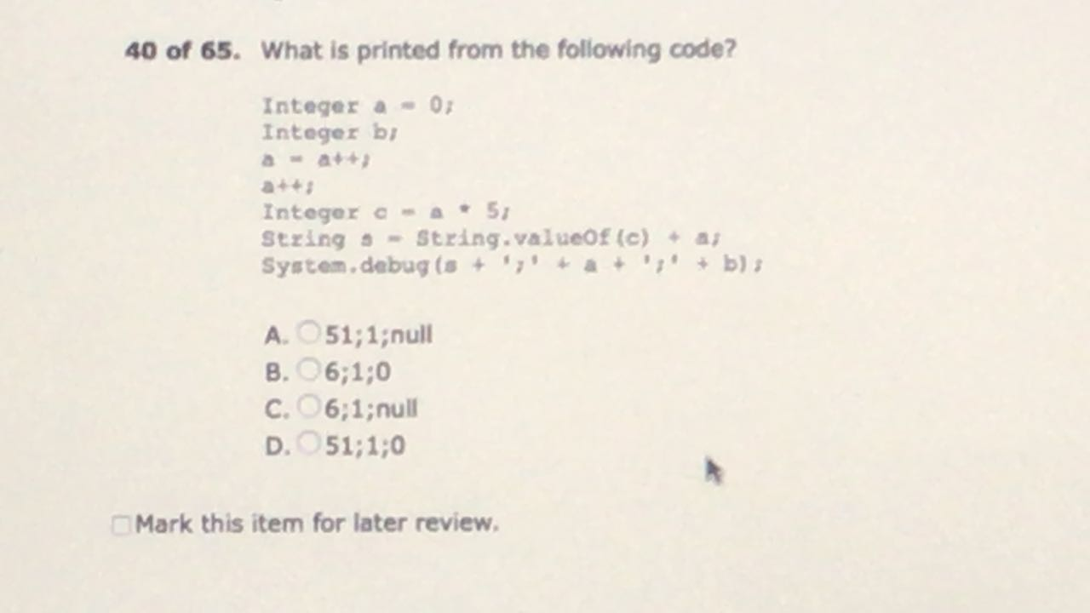

A

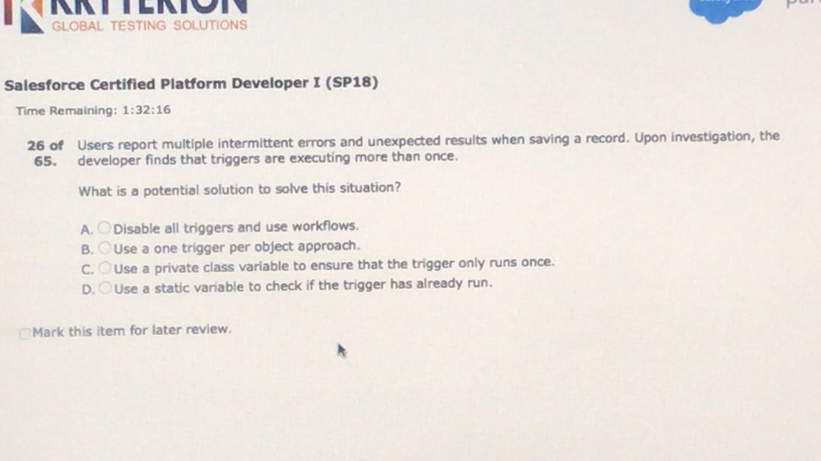

D.

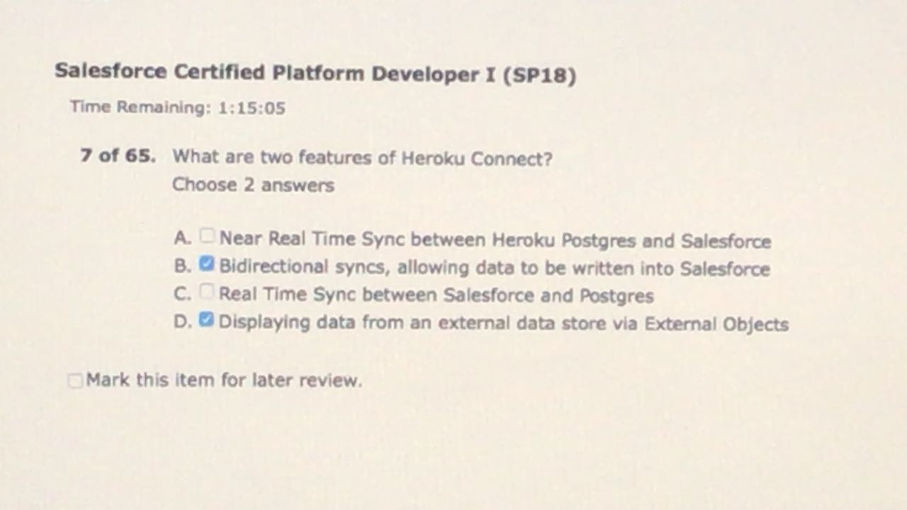

B,D

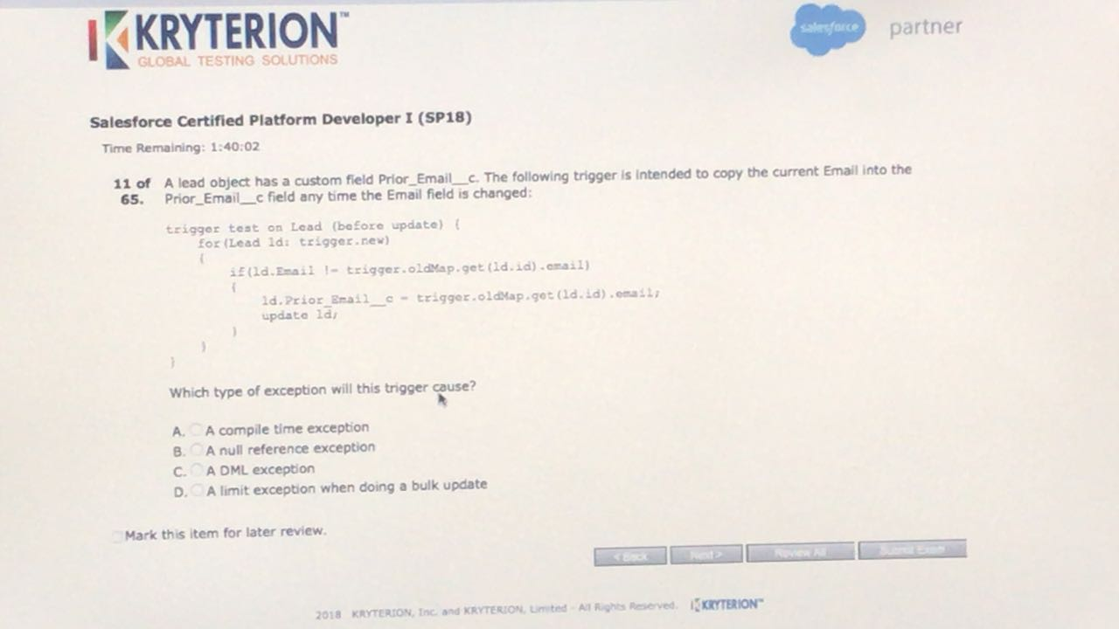

C

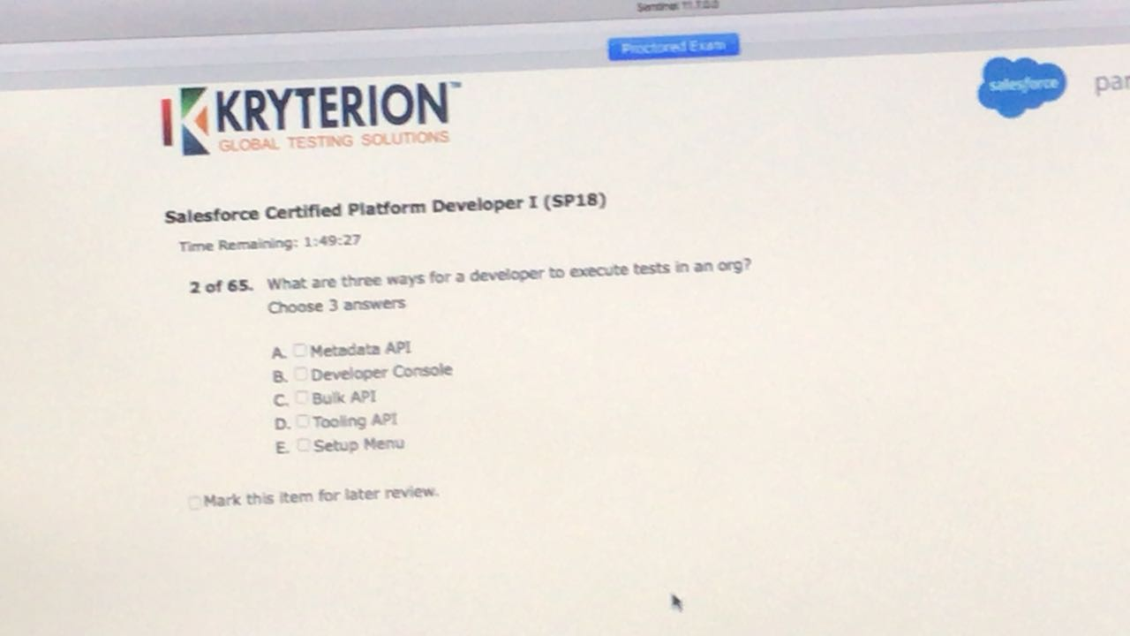

A,B,E

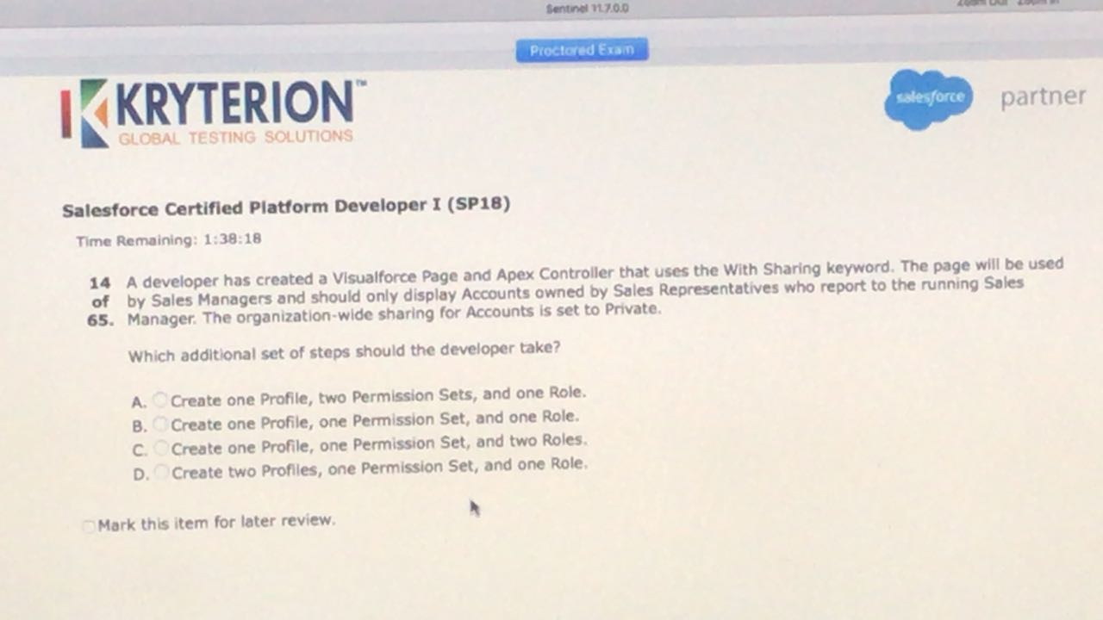

C

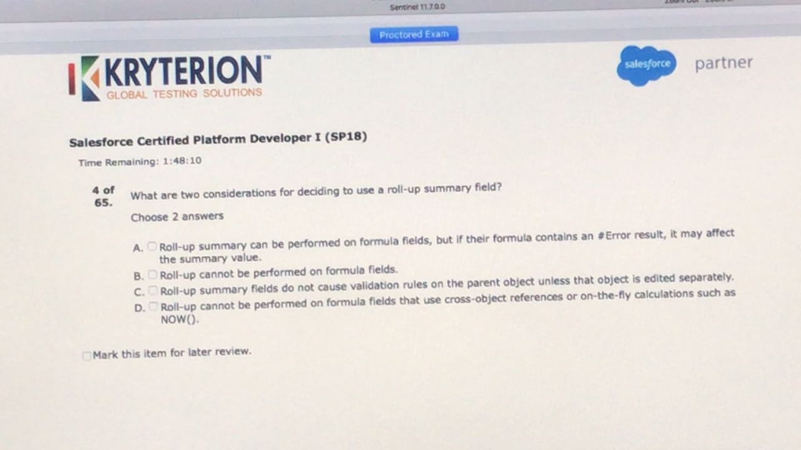

B,C

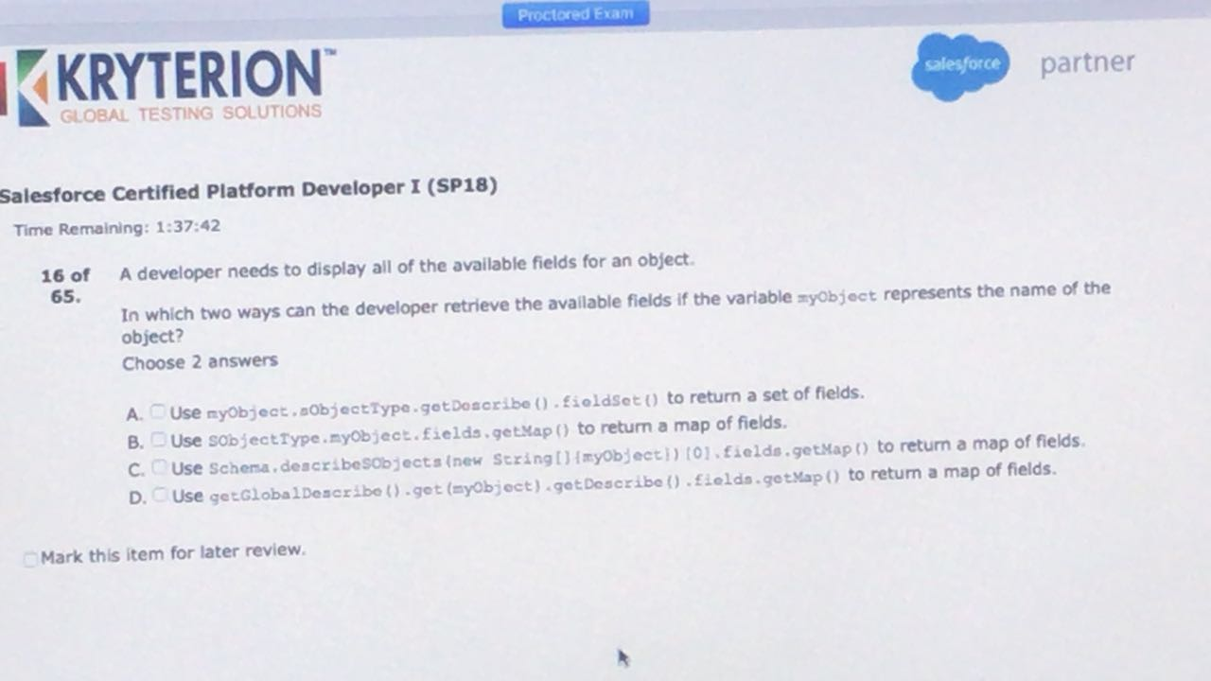

B,C

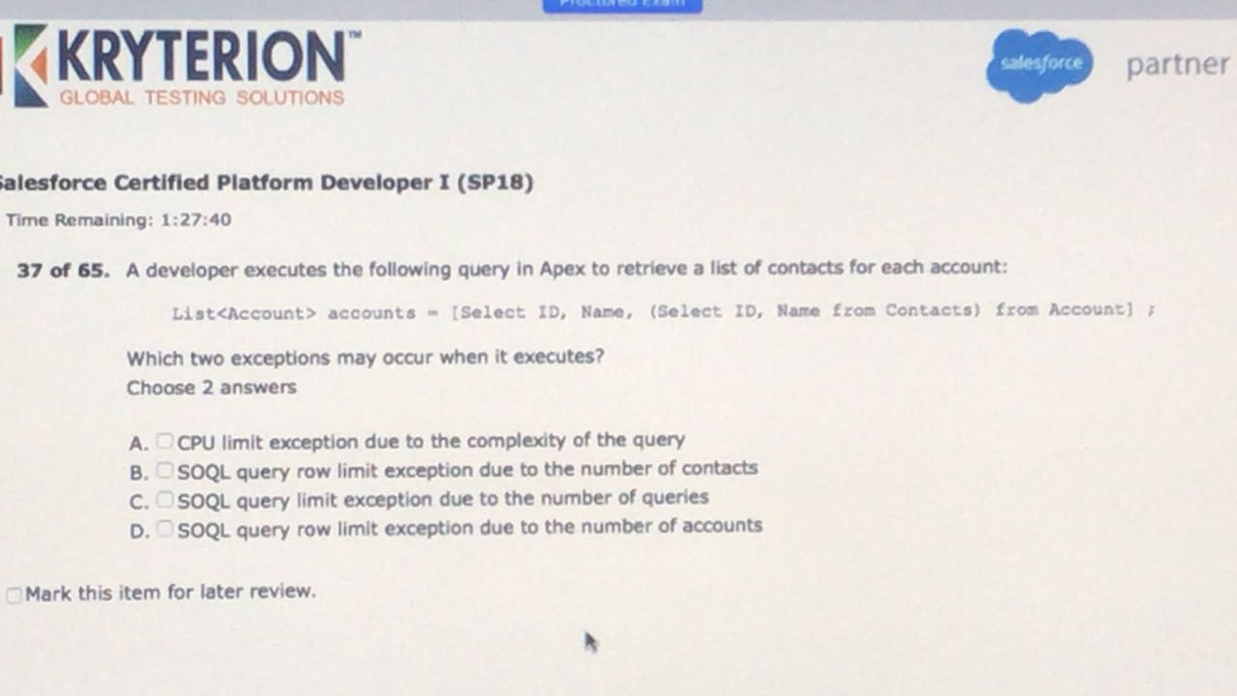

B,D

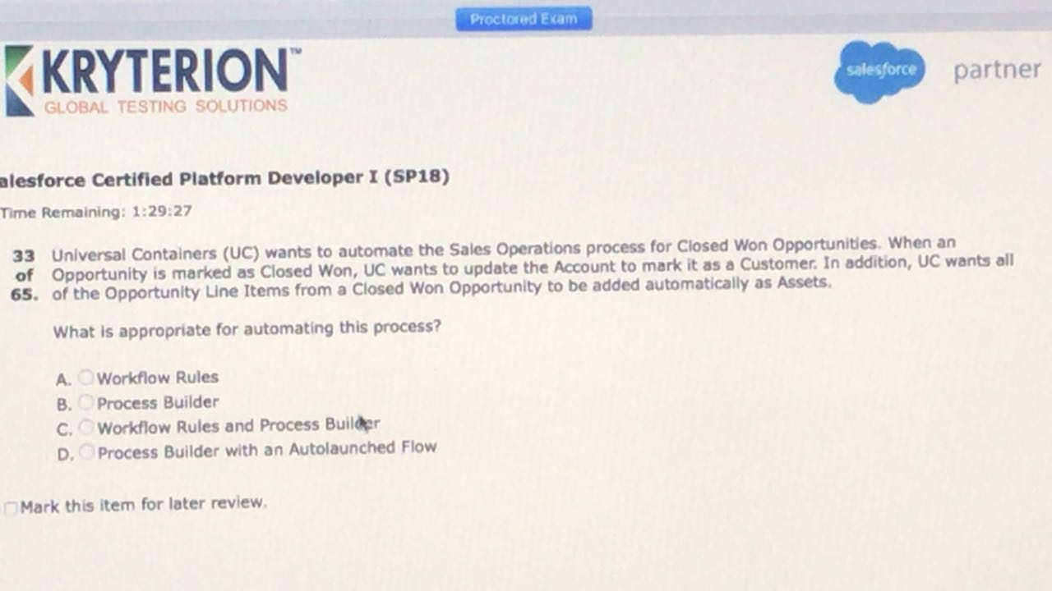

B

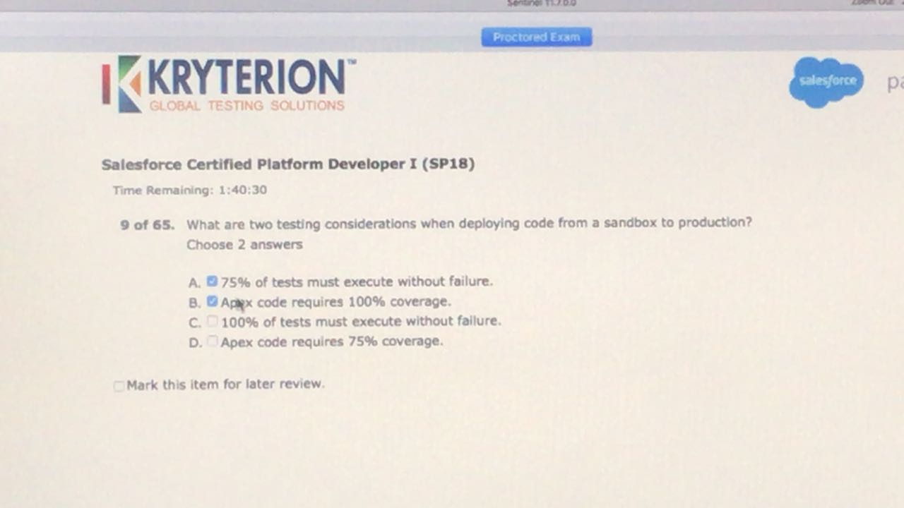

C,D

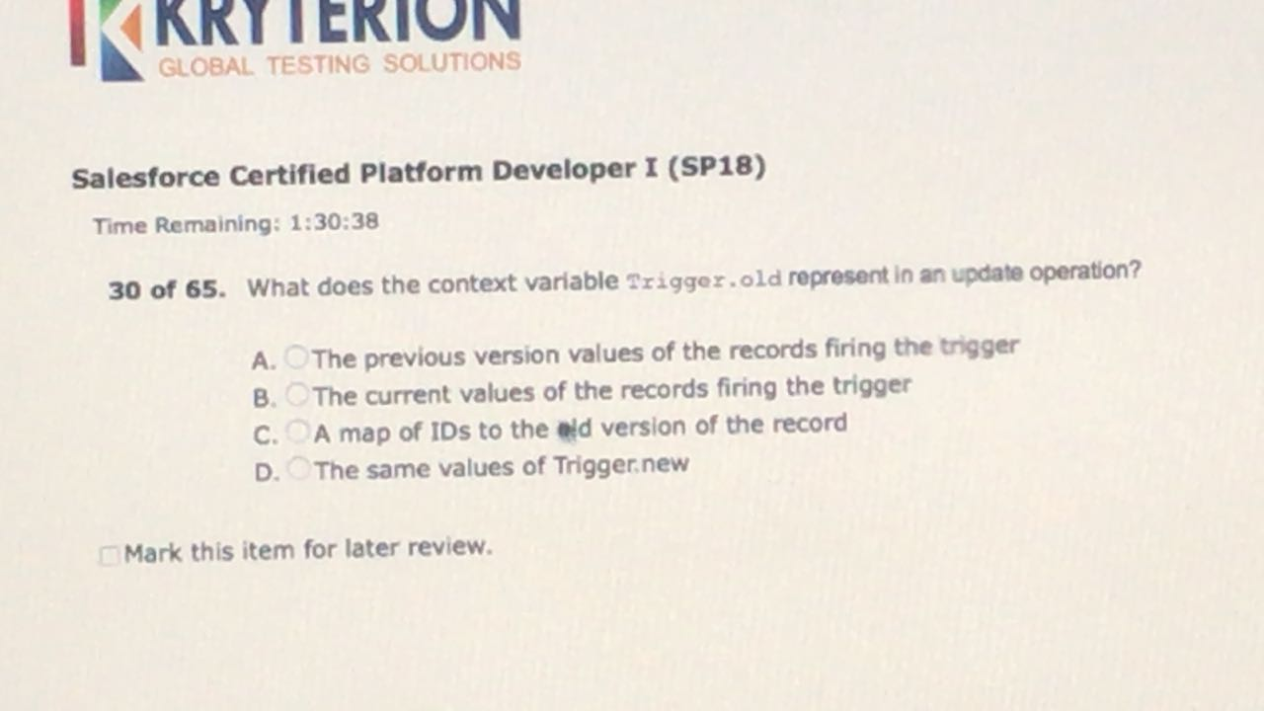

A

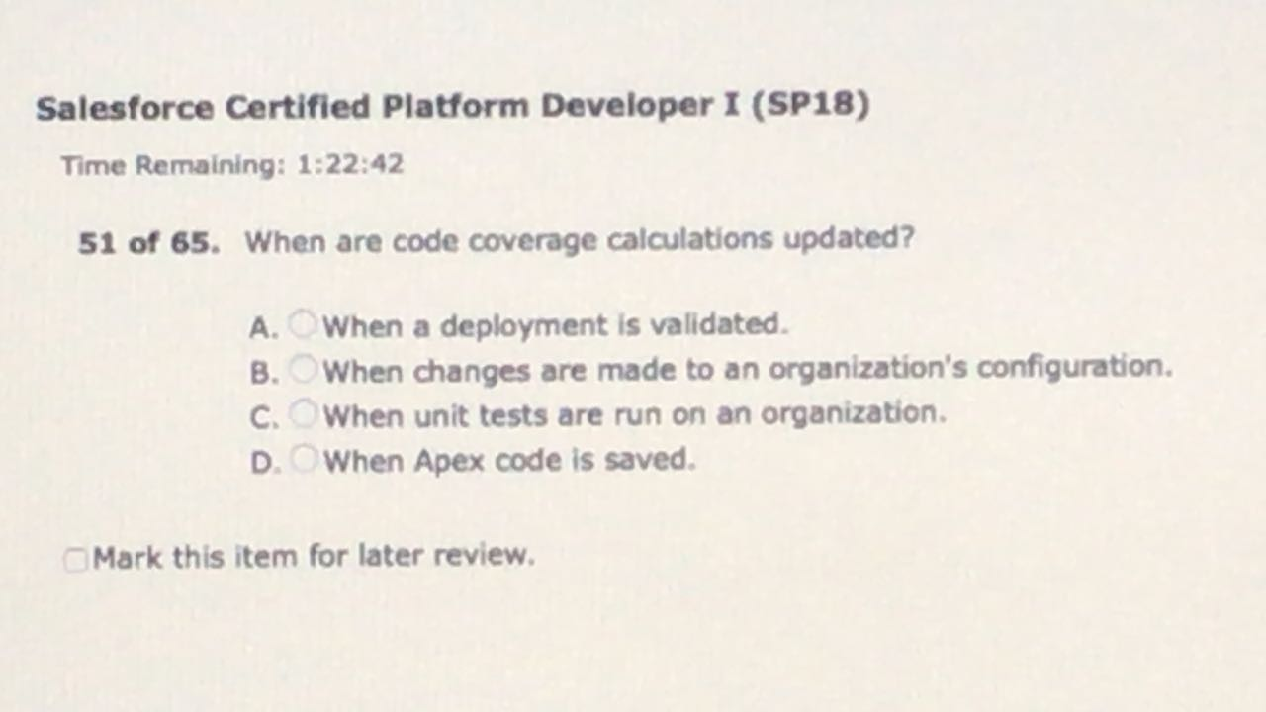

C

https://developer.salesforce.com/blogs/developer-relations/2012/11/how-code-coverage-works.html

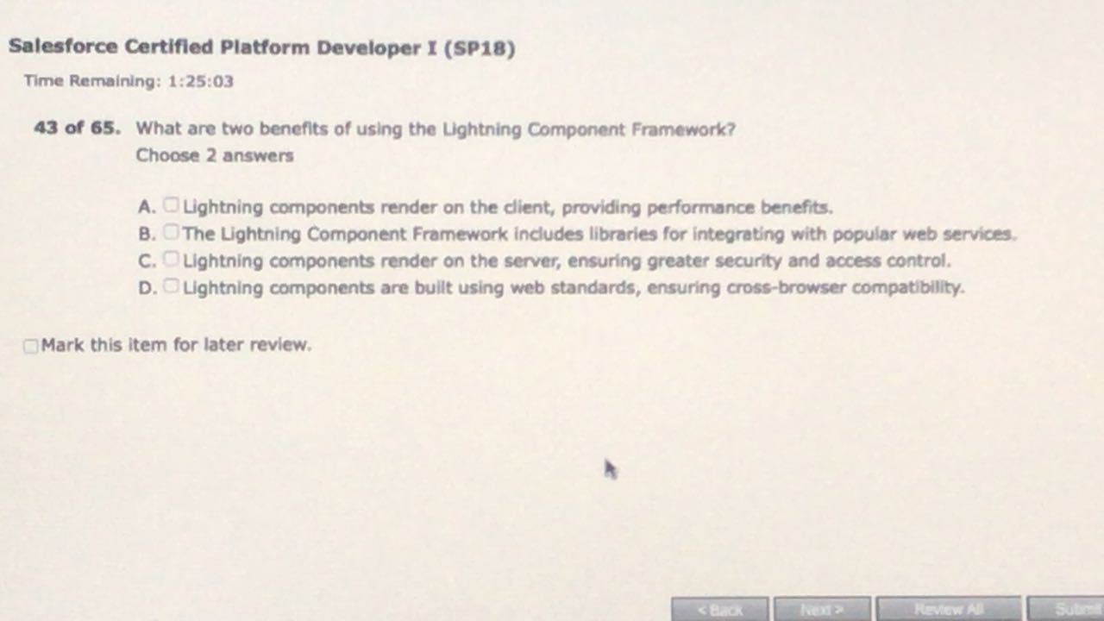

A,D

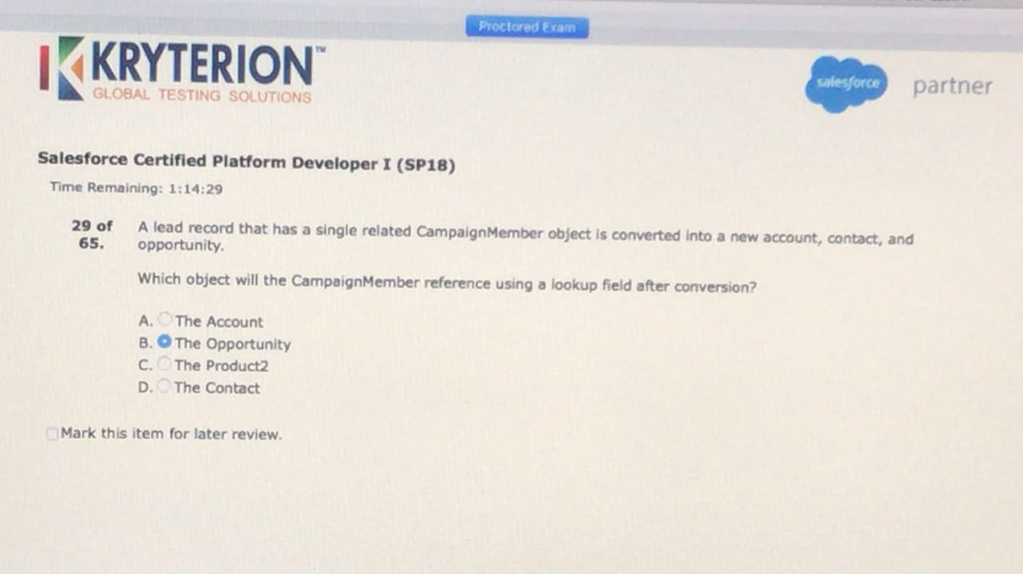

B